[Artificial Intelligence in the Life Sciences 3 (2023) 100057](https://doi.org/10.1016/j.ailsci.2023.100057)

 

Contents lists available at [ScienceDirect](http://www.ScienceDirect.com/)

Artificial Intelligence in the Life Sciences

journal homepage: [www.elsevier.com/locate/ailsci](http://www.elsevier.com/locate/ailsci)

Review

Application of AI techniques and robotics in agriculture: A review

Manas Wakchaure a,b, B.K. Patle b,∗, A.K. Mahindrakar b

a *Department of Mechano-Informatics, Graduate School of Information Science and Technology, The University of Tokyo, Tokyo, Japan*

b *Department of Mechanical Engineering, MIT School of Engineering, MIT ADT University, Loni Kalbhor, Pune, Maharashtra, 412201, India*

a r t i c l e i n f o a b s t r a c t

*Keywords:*

Artificial intelligent techniques Agriculture robots

Agriculture engineering Smart farming Cultivation

Monitoring Harvesting

The aim of the proposed work is to review the various AI techniques (fuzzy logic (FL), artificial neural network (ANN), genetic algorithm (GA), particle swarm optimization (PSO), artificial potential field (APF), simulated an- nealing (SA), ant colony optimization (ACO), artificial bee colony algorithm (ABC), harmony search algorithm (HS), bat algorithm (BA), cell decomposition (CD) and firefly algorithm (FA)) in agriculture, focusing on expert systems, robots developed for agriculture, sensors technology for collecting and transmitting data, in an attempt to reveal their potential impact in the field of agriculture. None of the literature highlights the application of AI techniques and robots in (Cultivation, Monitoring, and Harvesting) to understand their contribution to the agriculture sector and the simultaneous comparison of each based on its usefulness and popularity. This work investigates the comparative analysis of three essential phases of agriculture: Cultivation, Monitoring, and Har- vesting, by knowing the depth of AI involved and the robots utilized. The current study presents a systematic review of more than 150 papers based on the existing automation application in agriculture from 1960 to 2021. It highlights the future research gap in making intelligent autonomous systems in agriculture. The paper concludes with tabular data and charts comparing the frequency of individual AI approaches for specific applications in the agriculture field.

# Introduction

The ancient culture of any country deals with agricultural activities for the overall development for thousands of years. Agricultural activi- ties have an impact on human beings as per the energy requirements in terms of healthy foods are concerned. The growth cycle of any crop goes through three fundamental phases: cultivation, monitoring, and harvest- ing phases, and each phase have a number of activities. The cultivation phase deals with selecting crops to be planted, planning of land, land preparation, irrigation planning, seed preparation, and seed sowing. Af- ter the cultivation phase, the main task of farming is to monitor and control the growth of the crops. In this monitoring phase, the activities depend on time, such as scheduled crop health monitoring, fertilizer use, disease identification, weed identification, and pesticide spraying. At last, the most crucial phase of the crop cycle is the harvesting phase which includes the activities such as crop cutting, segmentation, storing, and selling to the market.

At present, most agricultural activities are traditionally practiced, re- sulting in non-profitable and non-economic farming. Traditional farm- ing without AI and robotics sufferers from

∗ Corresponding author.

*E-mail address:* [balu_patle@rediffmail.com](mailto:balu_patle@rediffmail.com) (B.K. Patle).

* It is more time-consuming and requires much effort to prepare and plan land, irrigation, and seed sowing.
* Involves more human resources for handling the various agriculture processes.
* Lack of accurate information on weather, soil conditions, and use of fertilizers.
* It takes more time and effort to monitor crops’ health and disease identification manually.
* It requires more labor for weed identification and control.
* Traditional spraying of pesticides affects the health of the farmers as well as reduces crop productivity.
* Old ways of crop cutting and segmentation of healthy crops and fruits are tedious tasks.
* Poor practices in storing harvested food led to its degradation.

Further, due to a lack of knowledge, experience, and problems in- volved in agriculture, many of the young generations are disconnecting themselves from agricultural activities, which will undoubtedly raise the question of future food production and the requirements. The agri- cultural development revolution took place from 1.0 to 4.0 (today) to overcome all these issues. It is replacing the traditional farming system with the most advanced AI-based system in which the machine itself makes the decisions for solving real-time issues. At present, young en- gineers and scientists are working a lot to make the agriculture process effortless, intelligent, cost-effective, highly productive, time-eﬃcient, sustainable, healthy, and wealthy society. AI-based systems include sen-

<https://doi.org/10.1016/j.ailsci.2023.100057>

Received 21 November 2022; Accepted 5 January 2023

Available online 6 January 2023

2667-3185/© 2023 The Authors. Published by Elsevier B.V. This is an open access article under the CC BY license (<http://creativecommons.org/licenses/by/4.0/>)

sors technology, IoT, data management technology, intelligent decision- making algorithm, robotics, and advanced mechanisms.

There are very few review papers available on the implementation of AI in the field of agriculture [1–7]. The available papers highlight the specific area of agriculture, such as weed identification and pesti- cide spraying, irrigation planning, crop yield monitoring and prediction, greenhouse automation, navigation and path planning, disease identi- fication, segmentation, harvesting of crops and fruits, etc. None of the available papers have considered the agriculture field’s overall processes and activities consisting of various phases such as cultivation, moni- toring, and harvesting. It is also seen that there is no systematic re- view available on the application of AI in the different activities of each phase. In most of the review works, the data is presented neither in tab- ular form nor graphically for easy understanding. The comparative data is also missing between the various cited papers. The available review papers do not provide that depth as they have considered minimal pa- pers for reviewing. The main drawback of the available review papers is the lack of explaining the existing research gap qualitatively as well as quantitatively in agriculture using AI.

The proposed review paper has been prepared after reviewing more than seven hundred papers and citing more than 150 papers for review work. In this work, we have presented a systematic review of AI tech- niques over various agricultural phases, including the path planning of agriculture robots. The paper highlights the major areas where AI is im- plemented most commonly, and it also highlights the areas where the application of AI is very much needed. The paper identifies the areas of agriculture where the improvement of the existing process may be enhanced using various available techniques. The proposed work shows the applications of various AI techniques and algorithms, which have been used widely, and identifies the techniques used as a hybrid model. Here, the analysis of AI is studied based on simulation work, experimen- tal work, application as a hybrid approach, and application for solving problems in agriculture. The detailed tabular analysis and graphical con- clusion are presented year-wise to make the review more understand- able. Using the in-depth proposed review, one should be able to dif- ferentiate the phases, such as cultivation and harvesting, that are still practiced traditionally. Most of the AI implementation is done in the monitoring phase only. The AI techniques such as fuzzy logic (FL), ar- tificial neural network (ANN), genetic algorithm (GA), particle swarm optimization (PSO), artificial potential field (APF), simulated anneal- ing (SA), ant colony optimization (ACO), artificial bee colony algorithm (ABC), harmony search algorithm (HS), bat algorithm (BA), cell decom- position (CD) and firefly algorithm (FA) have been proposed for rigorous analysis.

Here, the various AI approaches used so far in various agriculture

processes are explained in Section 2. Section 3 of the paper provides a detailed discussion of the AI approaches. The conclusion and future scope are provided in Section 4.

# AI techniques used in agriculture

The problems associated with various agricultural activities can be solved by implementing AI techniques (Fig. 1). The research work from the year 1960 to 2021 has provided numerous methodologies in the field of agriculture, and it is presented below.

* 1. *Fuzzy logic*

FL has many advantages over traditional decision sets. FL is a set of rules that solve problems with nonlinearity, complexity, and uncer- tainty. It was first introduced by L. Zadeh in 1965 [8]. The FL is the logical approach that gives a precise decision about the ongoing condi- tion with the value called degrees of truth. Like other traditional sets, FL does not give true or false results. FL, as an AI technique, helps the con- troller understand the correct changes with the time of the system in the

real world to take the precise steps to act upon with time. The develop- ment of FL in the last few years has evolved the decision power of con- trollers. Nowadays, the FL technique is widely used in the agricultural domain in various processes such as agricultural UAV navigation, aerial imaging, crop-cutting robot, farm monitoring, harvesting, and many more.

Decision and planning are very important in agriculture. The sud- den change in climate affects the farmer’s planning in the crop growth cycle. Shahjalal et al. [9] have worked on the FL model to analyze cli- mate change’s consequences on agricultural production. With this study, farmers can make the right decision to plant crops. Further, the applica- tion of FL for an understanding of carnation seedlings and their growth cycle parameters, such as shape, is presented by Fujiwara[10]. His-work presents the FL with an image processing algorithm and achieves a 97% judgment rate. The agriculture processes are complex, and it requires much effort to perform them within time. By considering this aspect, Nassiri et al. [11] have worked on the packaging of good tomatoes us- ing FL based classification model. The mature tomatoes were analyzed upon fruit color, size, and hardness. The hardness was tested by a fuzzy membership function and with an Instron compression test. Further, Collewet et al. [12] have proposed the fuzzy adaptive controller as a perfect control technique to help agricultural robots work more effec- tively in farming. They have used meta-rules, specialized learning ar- chitecture, and cell-to-cell mapping algorithms to achieve their goals. One such FL-based approach is developed and implemented by Hagras et al. [13] on agriculture robots to minimize human effort in harvest- ing crops. Hayashi et al. [14], Cho et al. [15], and Xue et al. [16] also worked towards the development of a vision-based fuzzy feedback sys- tem for agriculture robots. The work is more focused on the problems occurring during the harvesting of plants. They have used FL to help the robot arm to reach the fruit and provide feedback to control fur- ther tasks. While working on the farm, autonomous navigation is the biggest challenge for any mobile robot. Hence such a problem is ad- dressed by Borrero et al. [17], Kannan et al. [18], and Barakat et al.

[19] by developing fuzzy-based eﬃcient steering control action. The

same problem of autonomous navigation in the presence of complexity of crop row lines is also solved using FL with the sensor technology by De Sousa et al. [20]. The robot equipped with sonar-based map- ping and FL was developed by Toda et al. [21] to minimize the ef- fort in monitoring crops. In order to take proper care of crops, spray- ing pesticides is an important step in agriculture engineering. Abdel- latif et al. [22] presented an unmanned aerial vehicle based on FL to make fast and autonomous spraying of pesticides. In their work, FL is used to control the input signals from sensors to output to actuators. Cho et al. [23] have developed an FL controller to achieve fast opera- tions of spraying in the orchard environment. They used machine vision and FL to control the operation time of hydraulic cylinders. Similarly, one more application of vision-based navigation for agriculture robots is provided by Zhou et al. [24] using reinforcement learning and fuzzy rules.

The new concept of E-farming based on FL is given by Narendran et al. [25]. Their work is related to the agriculture robot, which is de- signed and developed using FL to control the microcontroller for precise movement of motors in performing multiple functions in agriculture, such as ploughing, seed dispensing, watering, pesticide spraying, and temperature monitoring. One more mild stone in the field of agricul- ture engineering is given by Prema et al. [26]. In their work, they have also provided the application of FL to control the robot from a remote location. They proved that the PID controllers are not eﬃcient com- pared with FL. Any intelligent systems need precise and proper input data from the sensor, but multiple vibrations in the mechanical systems disturb it. Paul et al. [27] have presented an FL-tuned PID controller for the agriculture manipulator vibration control to solve the problem. The non-linearity is controlled by using Type-2 FL. The recent work in UAV is presented by Nderu et al. [28] for perfect aerial images with the help of fuzzy technologies. For precision agriculture, the data monitoring of

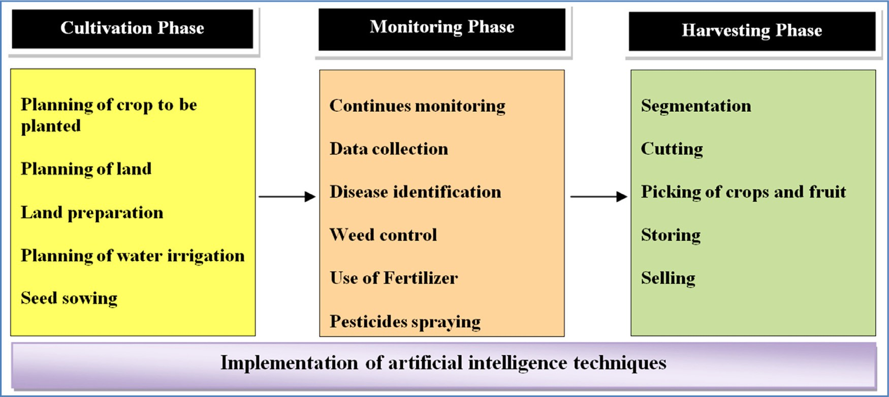

**Fig. 1.** Implementation of AI techniques for agriculture activities.

crops is much needed for proper controlling of plant growth. As per the authors, the fuzzy technique helps UAVs handle and overcome vague- ness and ambiguity. The FL is implemented with many other techniques in order to get maximum advantage in the same input. One such hybrid approach is presented by Morimoto et al. [29]. This work used FL, GA, and NN for greenhouse automation to reduce human effort. Noguchi et al. [30] have presented a hybrid approach using the FL and GA for precision farming. In their work, they focused on how to control weed as it affects the growth cycle of crops. The implementation of FL and GA is used to classify the plants and weeds separately. Hagras et al. [31] have implemented the FL and GA to develop autonomous agriculture vehicles for navigation based on crop lining, spray, ploughing, and harvesting. The application of the FL and GA-based hybrid approach is provided for autonomous speed spraying by Cho et al. [32]. Hagras et al. [33] have focused more on FL and GA to develop an intelligent agricultural robot to independently take their learning decision online while performing various farming tasks. The vital step in agriculture is crop inspection which is addressed by Camci et al. [34] using UAV. In that work, the AI algorithms such as FL, PSO, and NN are used to solve UAVs’ real-time challenges during an inspection of the crop.

The development of FL has also been seen for yield prediction, crop

needs recommendation systems and irrigation forecasting. As we know, the growth of crops majorly depends on humidity, temperature, and soil moisture. Upsdhaya et al. [35] have used FL with all these parameters to study the possibility of vegetable crop growth and yield. With these results, one can plan effective irritation methods. Similarly, Parbakaran et al. [36] have worked on FL and SVM agriculture yield prediction sys- tems. The system has a 95% of forecasting accuracy rate. Furthermore, the system also gives live crop needs recommendations to increase pro- duction. To control the use and need for soil fertilizers, Haban et al.

[37] have developed a soil fertilizer recommendation system using FL. The common fertilizer level data are used as the input to the system, and then the system will recommend the fertilizer needed. Likewise, Alfin et al. [38] have presented recommendations system using FL and vari- ous soil parameters to keep track of sugarcane plant needs. The system provided the perfect recommendation of water and fertilizer to use. As a control of action, Puspaningrum et al. [39] have presented FL-based Irrigation forecasting systems. The system controls the valve opening as per the forecasted needs of a crop.

* 1. *Artificial neural network*

The ANN is the trending area of research at present as multi-solution for complex problems is considered. It is inspired by the neural system of

the human brain, which acts emergently with the perfect action on the change by analyzing the effects. ANN is broadly used to solve dynamic complex problems because it works on the input, hidden, and output layers. These layers are perfectly organized as per the complexity of the problem. This layer is formed by an activation function called nodes. These nodes have different information and data sets used to analyze new input characteristics. The input layer continuously recognizes the set of input characteristics with pre-learn data sets. Afterward, these sets of characteristics are diagnosed with the help of hidden layers to give the highest matching solution from the data sets to the output layer. At last, the output layer provides a final solution.

The application of ANN is widely adopted in the field of agriculture for many aspects. Elizondo et al. [40] have presented their work on the ANN for predicting flowering and checking the maturity of soybean. Farmers are not able to predict their yield due to a lack of information on crop parameters. The authors have used air temperature, photope- riod, and days of flowing in this work as input to the ANN model. The ANN has been used in plant species classification using a deep convolu- tional neural network by Dyrmann et al. [41]. In that work, the ANN is used to identify the images of seedlings at early growth stages. Behroozi- Khazaei et al. [42] have presented a robust algorithm based on ANN and GA for the segmentation of grapes. Likewise, the apple recognition sys- tem based on a convolutional neural network was developed by Liang et al. [43]. The harvesting phase is the most critical phase, which de- pends on the product conditions and complexity of the environment. The algorithm aims to overcome these problems. They have used GA to optimize ANN for segmentation based on color. Similar to the above, the ANN-based sorting mechanism was developed by Kumar et al. [44] to decide between healthy or deceased pomegranate fruit. Dimililer et al.

[45] have developed a system that will help farmers identify unwanted plants in their land within 0.2 s. The system is based on image pro- cessing and backpropagation neural network techniques. The algorithm takes the images as input and provides the analysis as an output. The results have proved that the system is effective and robust to use. One more diﬃcult task is to cut and keep the required path of garlic, on which Thuyet et al. [46] have worked in which the process of sorting garlic by using a convolutional neural network for autonomous grad- ing is performed successfully. They have developed a fully automated computer system for garlic operation.

Many researchers in agriculture have practiced the implementation of the vision system with ANN. Cho et al. [15], Zhao et al. [47], Tang et al. [48], and Dorrer et al. [49] have used standalone ANN to provide vision intelligence in precision farming. Weed monitoring and control is a much-needed task in agriculture. The available classification system

has some limitations, such as being tested for each field of operation. To overcome this problem Hall et al. [50] have come up with a classi- fication model with low-dimensional features using deep convolutional neural network data collection (DCNN) algorithms. They have used it on cotton plants with a mobile platform and found pure cotton groups and weed groups. McCool et al. [51] present a similar work idea using lightweight models for agricultural robots based on lightweight DCNN and Champ et al. [52]. The hybrid approach using ANN-FL-GA is dis- cussed by Noguchi et al. [30]. They applied vision intelligence for weed control. Sa et al. [53] used the UAV for weed mapping. With the help of multispectral imaging and a deep neural network, they have generated a weed map for precision farming. The application of ANN to detect the state of the fruit (mature or immature) is one of the most challeng- ing tasks. Such a problem of strawberries is addressed using ANN by Habaragamuwa et al. [54]. The specialized machine vision system on an agriculture robot for harvesting such strawberries is designed using ANN by Ge et al. [55]. Path planning of agriculture robots is essential when moving on to the farm to perform a specific task. By taking it into consideration, the path-planning problem of agriculture robots us- ing ANN is addressed by Lulio et al. [56]. Bo et al. [57] have worked on path recognition methods for agricultural mobile robots in a shadow environment. In order to reduce the human effort in the greenhouse, the ANN approach can play an important role. To achieve this, Morimoto et al. [29] have provided experimental work on apple and orange farms, and observed results were up to the mark.

Deep learning models are very much eﬃcient in decision-making,

intelligent prediction, classification, and many more. Xenakis et al.

[58] have presented a diagnosis support system implemented on a robotics system for plant disease diagnosis using CNN. The deep learn- ing algorithm has performed out of the box with a 98% classification rate. Furthermore, to keep a close eye on healthy crops, Sharmila et al.

[59] have presented an insect classification algorithm based on the CNN and K-Means clustering algorithm. The results helped farmers to iden- tify the pest and take needed actions in time. Singh et al. [60] have highlighted the central problem of weed identification and have pro- vided a system powered by a region-based convolutional neural network (R-CNN) deep learning algorithm for crop-weed segmentation and de- tection. The system was also able to give the coordinates of the weeds for easy actions. Similarly, Mary et al. [61] have developed a weeding robot for weed control based on CNN. Using the deep learning model, the robot identifies the weeds and then performs drilling actions to kill weeds. The presented robot is eco-friendly and cost-effective. A deep learning model named as long short- term memory to forecast low tem- peratures zone is presented by Guillen-Navarro et al. [62]. Mhango et al.

[63] have worked on a potato plant mapping model using Faster region- based CNN and input from UAV. The work is performed in order to man- age and make essential decisions before harvesting potatoes. Further, Khan et al. [64] have developed a deep learning model for UAV’s pre- cise spraying based on an R-CNN. The live experiment showed the area in need of spraying with 88.57% accuracy. Deep learning models per- form excellently for the classification problem in the harvesting phase. Munir et al. [65] have worked on an Automatic fruit detection tool for easy harvesting using deep learning NN. They have used resNet-50 for transfer learning and have got results on 10% training.

* 1. *Genetic algorithm*

A GA is a met heuristic (evolutionary) algorithm used as an optimiza- tion tool in AI. It was introduced by John Holland[66] in 1960. The GA is the AI technique inspired by genetic principles and the steps of the natu- ral section to give us an optimal solution for complex problems. The GA is used in many industrial applications for the optimization of various processes. The genetic evaluation can be stated in every new genera- tion that is evaluated by crossover and mutation from old individuals. It will always have a new and mixed approach with strong species of in- dividuals as compared to old-generation individuals. Here some species

of individuals pass all the genes where some do not. Those who pass the genes form new species of individuals, and the process is repeated for every new generation of individuals. In a GA, the random popula- tion of individuals has taken, who goes through every individual and finds the best individuals with maximum fitness value. Here the condi- tion for solving the problem is there or not is checked. If not, then the process again goes for the new population by adding the genetic infor- mation (crossover) of the old best individuals, this individual’s species go through mutation, then we go for the section of an individual with the highest fitness value, this continues till we get the best fitness value of the solution for complex problems.

The GA has been widely adopted in the field of agriculture due to its effective working and accuracy in providing optimal results. The ap- plication of GA in the motion planning of a mobile agriculture robot is widespread. Various researchers such as Makino et al. [67], Dohi et al. [68], Ferentinos et al. [69], Ryerson et al. [70], Jihong[71], and Pham et al. [72] have presented the standalone GA algorithm for path planning of the agriculture robot. The problem of path planning of the agriculture robot is also solved using a combination of GA and other AI techniques as a hybrid approach. One such effort is provided by Noguchi et al. [73]. Moreover, the comparison of GA and PSO is shown by Mahmud et al. [74]. The application of a fleet of robots to work on various agriculture tasks and a multi-path planning approach is presented by Conesa-Munoz et al. [75].

The proposed work aims to reduce the time required and make it cost-effective to improve the performance in the path planning of agri- cultural robots. UAVs are very proficient in monitoring remote farms, but it involves multiple planning and problems. Singh et al. [76] have presented a new trajectory whose parameters are optimized with GA’s help. The proposed plan is a perfect projectile trajectory with the base station avoiding all the obstacles. It helps them to reduce energy require- ments. Coverage Path Planning of electric tractors depends on several factors. The new, improved GA was presented by Shang et al. [77] to op- timize all the factors affecting the path planning of electric tractors, such as reducing energy consumption, improving speed, and others. Some of the authors, such as Gao et al. [78] and Meng et al. [79], used a vision- based system with GA. They aimed to recognize crop rows for better planning. An improved GA performed the recognition of the crop row lines method. They found that GA is effective in finding navigation lines. Dacal-Nieto et al. [80] have worked on GA’s visual recognition system for potato classification. They have tried a system to classify potatoes based on their external defects and disease.

To improve crop production, weed control and soil nutrition con- trol are crucial factors as it affects crops’ growth cycle. Noguchi et al.

[30] have presented their study on precision farming. They have used FL with a GA to classify the crop and weed. A genetic algorithm opti- mized the input and output membership functions, and they tested the model on a soybean farm. Furthermore, Feng et al. [81] have worked on GA-optimized nutrient solution formula for cucumber crops. The model gives an optimal combination of N, K, Ca, and Mg concentrations in the solution. The proposed formula helps in high-yield and cucumber farm- ing. The effective planning of irrigation systems is equally important as other agriculture processes. Monis et al. [82] have developed the GA to optimize the design of photovoltaic (PV) irrigation pumping. The aim is to optimize the search space with the help of engineering rules and GA. This method is used to optimize the benchmark of a PV system for a real farm. Hence the total cost of the system was reduced. Ahmed et al.

[83] have provided the optimal sizing and economic analysis of the PV- Wind Hybrid power system for water irrigation using GA. The spraying of water or pesticides is a very time-consuming task, and hence automa- tion of such a task is very much needed. Cho et al. [32] have devel- oped an improved GA-fuzzy controller with GPS for spaying operation. Recognition systems in agriculture have been playing an important role nowadays. Tao et al. [84] have demonstrated the perfect recognition system using GA. In the presented work, automatic apple recognition and its picking are done using the combination of fusion of color and

3D features. Like this, Behroozi-Khazaeiet et al. [42] have given a robust algorithm based on ANN and GA for the segmentation of grapes. The har- vesting phase is the most critical phase, which depends on the color and complexity of the environment. The algorithm aims to overcome these problems. They have used GA to optimize ANN for segmentation based on color. They have found a success rate of 99.4% in finding grape clus- ters. Zou et al. [85] have studied the inverse kinematics solution for a precision watermelon-picking robot. They aimed to overcome problems such as speed, low precision, and not guaranteed watermelon yield rate. The model used is called Denavit-Hartenberg, which is based on GA and a non-linear genetic algorithm. For picking the Agaricus mushroom, a unique robot with three picking arms is being designed and developed. Jia et al. [86] have worked on an avoidance algorithm based on GA for the three picking arms. The presented algorithm is eﬃcient in perform- ing the picking without any collisions. Intended for automation in the greenhouse environment, Tong et al. [87] have used GA. In both works, the control technique is developed to optimize an unknown agricultural non-linear system.

* 1. *Particle swarm optimization*

A PSO is a well-known metaheuristic algorithm used in various en- gineering optimization problems. It was introduced by James Kennedy and Russell Eberhart in 1995[88]. The natural swarm behavior inspires a PSO algorithm to solve non-linear problems. The concept of PSO came into existence due to the remarkable capacity of birds and fish to under- stand and implement communication planning to reach their goals, such as searching for food when working in a group. The flock of birds does not need someone to lead them in search of food. They just follow the neighborhood birds and reach the goal with proper communication and teamwork with neighbors. Here, one thing that must be understood is that every bird has a valuable experience to support the flock in reaching its goal. The particle swarm optimization is based on this fundamental idea. Here the group of particles follows each other and helps to opti- mize the problem. Every particle has some value that contributes to the team reaching the target. The contribution of each particle by moving randomly to attend the best position with itself and with goal points is used to influence each other.

The PSO algorithm has many applications in various fields, and agri- culture engineering is one of them. Agricultural machinery needs ad- vanced control in order to face agricultural challenges. One of such chal- lenges of improving the control system of mobile agriculture robots by optimizing PID parameters using PSO is presented by Gokce et al. [89]. The simulation of the system was presented, and the results were out- standing. Wenhua et al. [90] have presented agriculture extra-green im- age segmentation based on PSO and K-means clustering. The same kind of problem is also addressed by Shi et al. [91]. In that work, the complex environment of the cotton field has been studied using PSO and K-means clustering for the cotton picker robot. Weikuan et al. [92] have used the PSO algorithm and De-noising algorithm to remove the noise from night vision images of the apple taken by an apple harvesting robot. Many re- searchers have developed the hybrid approach of PSO with other AI techniques to get more benefits and make the system more eﬃcient. In this regard, Li et al. [93] have come up with the hybrid approach of PSO and GA for the path planning of multiple UAVs. The proposed hybrid path planning approach aims to minimize the time required to cover the field in doing various agriculture operations such as field inspec- tion, crop health monitoring, and automated spraying of pesticides.

Deep learning models have many advantages over other traditional

models. Mythili et al. [94] have presented the modified DNN and PSO for crop recommendations in the cultivation phase. They used climate data and past crop production data in this work. The PSO-MDNN model was very effective in recommending an appropriate crop. The compar- ison of an approach based on PSO and GA presented by Mahmud et al.

[74] to solve the agriculture robot routine problem by their invention. In this, the agriculture robot has been tested for spraying operations

in the greenhouse. One more work on UAVs using the PSO-FL-NN hy- brid approach for monitoring the rice farm is presented by Camci et al. [34]. In their work, the whole mechanism is dedicated to analyzing the quality inspection of rice crops. Chaudhary et al. [95] have presented a new PSO algorithm named Ensemble PSO for crop disease identifi- cation. The results of Ensemble PSO are very impressive. The applica- tion of PSO as an optimization tool helps in decision-making. Ji et al.

[96] have demonstrated their work on recognizing green pepper in the greenhouse. The method is based on the least-squares support vector machine, which is optimized for better performance with PSO. They have given the input of processed green pepper’s shape, and texture features to PSO to get better and perfect green pepper parameters. Sim- ilarly, Zou et al. [97] have used the PSO AI technique to optimize the support vector machine (SVM) classification and disease identification rate. The results under natural background were very effective. Fur- thermore, Anam et al. [98] have also worked on apple plant’s leaf spot disease segmentation optimization using the PSO AI technique, and K means algorithms. With these systems, farmers can produce more and earn more. The seedling mechanism plays an essential role in the culti- vation phase to plant each crop in a particular pattern and reduce the same waste. The optimization and improvement of the design of a wheat centralized seed deeding device based on PSO are presented by Wang et al. [99]. Various seed and feeding device parameters were considered. They verified the results by simulation as well as by field test. In order to stratify the water requirements of the crop in all three phases of a crop growth cycle, Bulbul et al. [100] have worked on irrigation optimiz- ing scheduling systems using PSO. The system optimizes as per the crop type.

* 1. *Artificial potential field*

The APF method is used in a real-time application for the better and easiest way for planning to resolve problems. The APF method is in- spired by electric charge field generation. The Potential Field method was introduced by Khatib[101] in 1985. He considered that a point in the workspace is affected by the field generation from obstacles and the goal. As per his research, the obstacle has high potential. They behave like a positive charge repeals the attractive point (robot), which is con- sidered a positive charge, and the targeted position has low potential. They behave like negative charges to attract. The use of this method is observed to a more considerable for the path planning of the agriculture robot.

Longo et al. [102] have presented their work on the navigation of agriculture robots in vineyards. To achieve this, APF and a laser range finder, and GPS are implemented on a robot. Similar to this work, other authors such as Harik et al. [103] and Hou et al. [104] also used the autonomous vehicle by using APF for farmland work. Cheng et al.

[105] have focused their work on harvesting robots. In his approach, the APF approach is implemented on a manipulator to perform the picking operation of an apple. Xie et al. [106] have also presented APF method- ology for apple-picking path planning, but results are tested only in the simulation environment. Similarly, Nemlekar et al. [107] have pre- sented APF powered robotic arm for picking lime. They have used APF to reduce the time of finding low-cost paths to the destination (lime). In order to develop a mobile platform for environmental monitoring and management, Martinovic et al. [108] have incorporated sensor-based technology with APF. In the proposed work, the greenhouse microcli- matic environment is controlled using a mobile measuring environment. Jihong et al. [71] have provided the APF-GA-based compering approach to address a seeding machine’s path planning in agriculture applica- tions. The APF method is mixed with other AI techniques to develop hybrid approaches, Tiexin et al. [109] have developed a hybrid APF- ACO approach for path planning of agriculture robots. The application of APF in UAVs for path planning and inspections of crops is shown by Yingkun[110].

* 1. *Simulated annealing*

The SA is known as the global optimization AI technique, which helps in solving large complex optimization problems. The SA is inspired by analogy due to its capacity to work on physical annealing and solids. The SA algorithm was introduced by S. Kirkpatrick [111] in 1983. This SA is known as the probabilistic technique as it focuses on the heat treat- ment methods and the changes happening in the metal because of heat treatment. The metal in the heat bath is taken to the highest tempera- ture, where it starts transforming from a solid to a liquid phase. Here the particle takes random positions in the liquid phase. After that, it cools down slowly and gradually reduces the temperature of the heat bath. All the random positions were taken by particles arranged in such a way that they would be in a low-ground energy state (Fig. 12).

In the agriculture field, the major application of SA has been seen for the motion planning of autonomous agriculture vehicles. Ferentinos et al. [112] have proposed a model to solve the real challenges of the agriculture field by using the SA. They compared the performance of SA with GA. It is observed that the SA gives a better solution related to the problem of multiple path planning [113] in agriculture farm con- ditions, and route planning of multiple agricultural vehicles [114] is addressed by various researchers using SA. Whereas in the cultivation phase, to optimize aerating (agricultural machinery used to lose the soil) performance on salt-affected agricultural lands, Zhang et al. [115] have designed and developed a five-bar aerating mechanism. They have used SA to optimize various working parameters. The application of SA as an eﬃcient monitoring technique is introduced by Andersen et al. [116]. They have improved the traditional method of monitoring using SA with a stereo vision to get a perfect estimation of plant properties. Weed and pest controls are critical issues in agriculture. Gonzalez-De-Santos et al. [117] have addressed such problems in agriculture using UAV and UGV. The planning strategies in the software are developed by using SA. The water irrigation system has a critical role in agriculture. Hence, the problem of optimal on-farm irrigation scheduling using SA has been proposed by Brown et al. [118] and Perez-Sanchez et al. [119]. Cong et al. [120] have worked on designing the scheduling model with the help of SA for agricultural tractors to work eﬃciently in a particular area. They have considered many factors, such as farmland area, agri- cultural machinery, etc., and found that the SA model is more eﬃcient than other AI techniques, such as GA. Similarly, the harvesting activity scheduling model using SA and GA is presented by Qingkai et al. [121]. The model was very stable and effective in performance.

* 1. *Ant colony optimization*

The study on ants has concluded that ants have a natural vision sys- tem like other insects. However, they plan their way very eﬃciently by optimizing the complexity of the real world. The ACO algorithm is help- ing many real-world problems to get optimum. An ACO algorithm is a metaheuristic algorithm used as an optimization tool. ACO was intro- duced by Marco Dorigo on the way back in 1992 [122]. The algorithm works on the thinking and idea of ants taking the shortest possible solu- tion. Ants are very brave in making decisions, such as shown in Fig. 14. Whenever they target the food, they plan their way to be short of their starting location. Every ant has a natural ability to secrete on the ground the biological substance known as a pheromone, which is the signal to be followed by others as a pathway. In this way, they guide each other to find and follow the shortest path. ACO is one of the advanced swarm intelligence algorithms, and therefore it is now adopted in the field of agriculture engineering.

The implementation of the ACO algorithm is increasing day by day in agricultural practices. The operation of route planning of the agricul- ture field using ACO is presented by Bakhtiari et al. [123]. Furthermore, Cao et al. [124] studied the management of agriculture machinery and proposed an ACO model to perform eﬃcient task management. They have performed simulation experiments for dynamic and static task as-

signments. The aim of both the study is to decrease the operational cost required in the agriculture sector. The agriculture robot is one of the essential pieces of equipment nowadays for improving the performance of various agricultural processes. The path planning of such a robot by using the ACO algorithm is presented by Zhou et al. [125]. They have demonstrated the path planning of the robot using ACO in the presence of an obstacle. The main aim of the proposed work is to save time as well as the cost of farming operations. Jiang et al. [126] compared the ACO’s performance with the GA and standard sequence method (CSM) for replugging tour planning of seedling transplanter, and it is observed that the ACO gives better results when compared to GA and CSM. The application of ACO for UAVs is presented for agriculture purposes by Yang et al. [127]. This work proposed that the path planning approach is developed for UAVs to take maximum information quickly by using ACO. An intelligent UAV irritation system that implements an ACO al- gorithm to find the optimal path is developed by Gao et al. [128]. The proposed algorithm had very eﬃcient results. To increase the perfor- mance of agriculture robots in path planning, the hybrid ACO- APF ap- proach is presented by Tiexin et al. [109]. On the adoption of the hybrid approach, performance improvement has been observed as compared to standalone ACO. The application of ACO as an optimizer in the crop rec- ommendations system is presented by Mythili et al. [129]. The ACO is used to optimize network inputs and the complexity of training weights of the crop recommendations system.

* 1. *Artificial bee colony algorithm*

The ABC algorithm is one of the best-developed swarm intelligence approaches for solving multiple complex problems. It is a metaheuris- tic algorithm used as an intelligent combinatorial tool. The algorithm was inspired by the intelligent behavior of honeybees in haunting their way for food with proper communication and dedicated teamwork. The ABC algorithm was introduced by Dervis Kharaboga [130] in 2005 to solve complex real-world problems. The colony of honeybees has three types of bees named employed bees, onlookers, and scout’s bees. All of them have some jobs, which helps them collect food intelligently in less time. The employed bee visits the food sources, looks for the status of the source, and saves the same information (Fig. 16). After completing the finding process, they inform the bee waiting in the dance area by waggle dance. The bee waiting in the dance area, known as onlooker bees, analyses the food sources by understanding the waggle dance of employed bees and selecting the food source compared to the initial one. If they identify the food source as of no use, then the onlooker bees send scout bees to find new food sources.

Selvakumar et al. [131] have presented an intelligent system for the garlic advisory system. They have also compared a rule-based algorithm and found that implementing the ABC algorithm is better and more ef- fective. The advisory system is a web-based application with an ABC algorithm and machine learning. Land planning and preparation play an essential role in any crop growth cycle. Bijandi et al. [132] have presented a model based on the ABC algorithm to improve land par- titioning. They have considered the results on the irrigation eﬃciency and found the layouts obtained from the model to be more effective. The use of wireless sensors in the agricultural sector to monitor crops is increasing, and so is the data. Sathish et al. [133] have worked on opti- mizing the data aggregation of these sensors using the ABC. They found out the ABC is more eﬃcient than GA. The application of the ABC algo- rithm for fruit image recognition is presented by Li et al. [134]. In their work, the machine vision system with ABC has been implemented for the recognition of fruit, and results are demonstrated using simulations. Navigating agriculture vehicles is a challenging issue in farm conditions; hence to avoid the error in accuracy, Kumar et al. [135] have presented a comprehensive Kalman-filter-based ABC approach for dynamic turn- ing issues. The authors also worked on the precise positioning of UAVs using ABC and GPS for additional effort in monitoring and inspection of crops [136].

* 1. *Harmony search*

Musical notes inspire the HS algorithm, and it was introduced by Geem et al. [137] in 2001. The HS algorithm is a metaheuristic al- gorithm based on audio processing with a set of rules for optimizing the effects of errors for better decision output. Audio processing deals with pitch level control for one specific harmony as output. The perfect audio pitch is stored, and the experience is used to create perfect har- mony in the coming time. The algorithm selects the perfect solutions from all the available information and experience for the ideal problem optimization.

Mandal et al. [138] have presented a prediction model based on the HS algorithm of mustard plant productivity. To overcome the challenge of predicting the crop life cycle to find its yield has been undertaken in this paper. They had input as a short length of the crop. Also, they have compared the approach with other AI algorithms for performance eval- uation. Valente et al. [139] have proposed a new approach using HS for aerial coverage optimization in precision engineering management. The HS results were compared with an approach based on a wavefront plan- ner, and they found the results of HS are better for optimizing routes and time. The hybrid approach of HS and NN is addressed in precision agriculture by Sabzi et al. [140]. The developed approach using a vi- sion system is used for weed identification in potato crops. Similarly, Pourdarbani et al. [141] and Sabzi et al. [142] have also developed a hybrid approach using HS-NN to recognize fruits in garden conditions and orchard environments.

* 1. *Bat algorithm*

BA is a metaheuristic algorithm used as an optimization tool based on swarm intelligence. It was introduced by Yang [143] in 2010. A BA is inspired by the microbats to find their path with echolocation. Mi- crobats are very small; being so small, they produce substantial sound waves and hear back the echo that is reflected from the assumed ob- jects such as prey or food. Every bat uses a random path and velocity to find the assumed thing while emitting different varying frequencies and wavelengths. The distance to reach the object is also calculated by the bat in seconds. They can control all the above parameters based on their goal. The ability to control and assist frequency is called frequency tun- ing. So, the BA is sometimes called a frequency-tuning algorithm also.

There are very few papers that provide the application of the BA in agricultural processes. The application of BA in crop image classifica- tion is provided by Senthilnath et al. [144] to monitor crops eﬃciently. Moreover, understanding the plant’s needs is very important in the mon- itoring phase of any crop growth cycle. One of the essential parameters is water stress. Azimi et al. [145] have used two data sets of plant shoot im- ages taken from different moisture conditions and used a BA-optimized model to get the optimal values of water stress classification. They found that BA has very accurate results as compared with traditional methods. Further, Yaseen et al. [146] have explored the problem of water irriga- tion and have presented a hybrid BA-PSO AI technique for optimization. In agriculture, pipe network planning is very much important. Accord- ingly, Lyu et al. [147] have demonstrated the tree-type irrigation system using improved BA.

* 1. *Cell decomposition*

It is one of the oldest methods especially used for the path planning of automated devices. The process of cell formation inspires it. The method takes a free area and allots a cell to that free area in the workspace. These allotted cells then form a path to reach the destination, which is represented by a contacting graph. If there are any obstacles, those cells are further divided into two sub-free compartments in that area, which again get added to all free cells to reach a goal in minimum time. CD is very effective with a modern algorithm for optimizing the problems, especially for the vehicles used in agriculture.

Linker et al. [148] have presented their study on the navigation planning of agricultural vehicles in the orchard environment. The nav-

igation approach is based on a modified CD and A∗ algorithm. The

compaction. The same work using CD and D∗ Lite algorithm is pro- work was shown for shortest path planning and to take care of soil

posed for robot path planning for the oil palm plantation environ- ment by Juman et al. [149]. Apart from this, the application of CD

and A∗ for robot path planning to save power and effective use is

provided by Santos et al. [150]. One more path-planning approach to

strategy is developed using CD and A∗ to make multiple path strate- avoid more soil compaction is presented in [151]. In this approach, the

gies to avoid soil compaction because of repeated movement of the vehicle.

* 1. *Firefly algorithm*

The development of the firefly algorithm is based on the firefly’s behavior. The idea was proposed by Yang [152] in 2008 as a newly inspired natural metaheuristic algorithm. It is a modern natural meta- heuristic algorithm. The behavior of fireflies, as they have light-emitting power, they hunt the food by this light such that the blinking of light in such a pattern so that the food/prey get attracted towards them. Also, they use it to communicate with their friends in their group. The firefly is brilliant in protecting and uses the blinking of light as a signal for protection. The male-female connection is also made with the blinking of light in a specific pattern. Even the female firefly uses this advantage to hunt other species. Communication and food-finding are based on blinking light intensity. The firefly algorithm is a beneficial technique to optimize a very complex problem such as agriculture management.

The agricultural sector is dependent on the irrigation system. Hos- seini et al. [153] have worked on optimizing the operation of a reser- voir for agricultural water supply. They have used the firefly algorithm with the objective function based on demands and supply of water. The results found by them were much better than those by using GA and PSO. Similar work was presented by Wang et al. [154] with NDFA (new dynamic FA). Garousi-Nejad et al. [155] have implemented FA as an optimization tool for irrigation supply and hydropower generation man- agement to improve farmers’ income.

# Discussions

The proposed review paper provides an in-depth analysis of more than 150 papers on the contribution of intelligent techniques and de- vices in the agriculture field. The literature on the agriculture field is classified into three important phases: cultivation, monitoring, and har- vesting (Table 2). The cultivation phase deals with the selection of crops to be planted, planning of land, land preparation, irrigation planning, seed preparation, and seed sowing. After the cultivation phase, the main task of farming is to monitor and control the growth of the crops. In this monitoring phase, the activities are dependent on time, such as sched- uled crop health monitoring, fertilizers use, disease identification, weed identification, and pesticide spraying. At last, the most crucial phase of the crop cycle is the harvesting phase which includes the activities such as crop cutting, segmentation, storing, and selling to the market. All these phases were studied under the influence of AI techniques such as FL, ANN, GA, PSO, ACO, FA, BA, APF, ABC, HS, CD, and SA. Although

there are various AI techniques available, only a few AI techniques have been shortlisted based on their popularity in agriculture activities and applications. From the literature review, significant progress is noticed in crop production, quality of food, farmer’s income growth, plant care, reduction in manpower, inspection, and monitoring of farms, and se- lective harvesting by using AI and modern tools. In some indoor appli- cations, AI plays a vital role in automatically controlling temperature, humidity, light, fertilization, and phytosanitary treatments. The com- mercial robot with AI implementation can be used in dealing with the

whole process of agriculture, from planting to packaging. All these ad- vantages of AI over traditional methods improve the technical and eco- nomic eﬃciency of farming. A remarkable change has been observed in modern agriculture in improving the health and safety concerns of the farmers.

The proposed paper presents a well-organized study of various avail- able research papers in which AI is implemented in the agriculture field. From the deep study of more than seven hundred papers, we have con- sidered more than 150 research papers for writing reviews on the con- tribution of AI in the area of agriculture. All the used papers have been classified (like FL, ANN, GA, PSO, ACO, FA, BA, APF, ABC, HS, CD, and SA) and sequenced properly in Table 1, as per the publication year to understand the development of AI in agriculture. In Table 1, the exami- nation is done in several categories, such as simulation work, experimen- tal work, hybrid approach, various phases (cultivation, monitoring, har- vesting), path planning, and usage of agriculture robots. Fig. 21 shows the number of papers available on 12 individual techniques and the fre- quency of these techniques used in the field of agriculture. It is clear from the figure that the implementation of FL, ANN, and GA is more common than other AI techniques. The techniques such as PSO, APF, SA, ACO, ABC, HS, BA, CD, and FA have limited papers in the agricul- ture field. Therefore, an enormous scope is there to work on these tech- niques for future advancement in agriculture. Fig. 22 shows that nearly 32% of work is done on the path planning of agriculture robots, 31% on monitoring, 19% on cultivation, and 18% on harvesting. It is crystal clear that the use of AI techniques is more common for path planning of agriculture robots followed by monitoring applications, and it also highlights the phases such as harvesting and cultivation where more improvement is much needed. In a comparison of experimental and sim- ulation work done in agriculture (Fig. 23), it is noticed that 46% of the work is presented using simulation, and only 54% of the work is done experimentally. This exposes that there is still a need for conversion of simulation work to experimental work in various agriculture domains. In a comparison of the standalone AI approach with the hybrid AI ap- proach from Fig. 24, it is examined that the standalone techniques are more common. Nearly 78% of the papers are available on standalone approaches and 22% on hybrid approaches. So, one should think about developing hybrid approaches to make a more optimized and eﬃcient approach.

The number of papers available on individual techniques to address

applications in the cultivation, monitoring, harvesting, and path plan- ning of agriculture robots is shown in Fig. 25-36. From the given bar charts, we can analyze that FL is the most preferred AI technique to solve agricultural problems, followed by GA and ANN. Very few of the techniques, such as FL and GA, are used more in all the phases of agricul- ture and path planning agriculture robots, followed by ABC, ACO, PSO, and SA. A more significant number of papers for the cultivation phase is addressed using FL, GA followed by PSO, and SA; in the monitoring and harvesting phases, ANN followed FL, and PSO is much preferred by various researchers. The application of AI to path planning of agricul- ture robots is carried out majorly using GA, followed by FL. As per the research concern, there are no papers available on the cultivation phase using ANN, APF, and HS. The same case is observed using CD and FA, as there is no work mentioned in the monitoring phase. Similarly, the AI techniques such as BA, CD, and FA have no more work available in the harvesting phase. From the graphical analysis of all techniques, one thing is very clear: the application to path planning of agriculture robots is addressed by all the mentioned techniques except BA and FA. The tabular and graphical data mentioned in the review paper clearly shows that the AI techniques such as PSO, APF, SA, ACO, ABC, HS, BA, CD, and FA need more attention to solving agriculture issues. These techniques can be upgraded by hybridizing with FL, ANN, and GA to get more no- ticeable results. This may be the future research gap in the field of agri- culture for performance enhancement and technological development. Further, the work must focus more on developing more experimental work than market-ready techniques. From the analysis of Fig. 37, the

application of robots in the monitoring phase is highlighted by 43% of work, followed by 38% in the harvesting phase and only 19% in the cultivation phase. More development of agriculture robots is needed in the cultivation phase. From Fig. 38, it is clear that the application of FL (21), GA (16), and ANN (16) to the development of AI-based agri- cultural robots is significant, and the application of APF, SA, CD, PSO, ACO, ABC, and HS is significantly less. No papers highlight the applica- tion of BA and FA to the development of AI-based agricultural robots. There will be a need to develop robots for all phases with the fusion of various advanced AI techniques and modern technology in the coming time.

From the study, we can analyze that the contribution of FL, NN, and GA is very significant. Out of 148 research papers, 31 research papers highlight the contribution of the FL to agriculture. In the late ’90s, the implementation of FL was only seen for the monitoring phase and the improvement of robotics technology. Later on, from the 20′s, FL con- tributed significantly to agricultural robotics technology to solve various agricultural robot navigation and control planning problems. The UAVs have been developed and optimized with the help of FL to monitor the crops’ health and take necessary control actions. The recent develop- ment of FL also can be seen in the cultivations phase. FL-based crop- recommended systems and crop production planning are very much popular now a day. Along with the time, the FL is significantly used in the harvesting phase, especially for fruit, lettuce plants, and tomato harvesting. It is observed that the available research on FL contributes more towards the monitoring phase as compared to harvesting and cul- tivation.

The NN is one of the popular AI techniques used for various agri- culture processes. Out of 148 referred papers, 29 research papers are contributing to various agricultural applications, especially in the mon- itoring phase. In the late 90 s, the application of NN was focused on mon- itoring phase activities such as checking maturity, greenhouse monitor- ing, and crop and weed classification. The implementation of NN from the 20′s, is not only seen in the monitoring phase but also in the har- vesting phase. Vision-based navigation using NN is one such example of making intelligent robots for smart farming. The segmentation, classifi- cation, and mapping applications are the more significant functions of the NN that are now implemented on agricultural robots and various in- telligent equipment of farming. Deep learning algorithms such as deep convolutional neural networks and region-based convolutional neural networks are very common for solving agricultural crop classification problems. The deep learning model named as long short-term memory is also found to be in forecasting low-temperature zones. The develop- ment of NN and deep learning models have significantly contributed to solving the problem associated with the monitoring and harvesting phase activities. Many of the deep learning models are majorly imple- mented on agriculture robots to perform precise agricultural activities. The contribution of NN and deep learning models are not seen in the cul- tivations phase activities, and it is one of the areas where more attention is required.

Similarly, GA has been widely accepted for the development of over-

all agriculture activities from cultivation to monitoring and monitoring to harvesting. Among 148 research papers, 24 research papers are cited for the contribution of GA in smart farming. Like NN, the contribution of GA is also seen to be remarkably less before the 90 s. The primary appli- cation in those times was only for crop care activities and path planning of agricultural robots. With the development of modern technology and AI, the applications of GA for the development of agriculture robots have been extraordinary since the 20′s. GA has been found to be very eﬃcient for various agricultural activities and the associated problems such as path planning, precision fruit picking, spraying, classification, segmen- tation, and many more. The GA has also contributed to the optimization problems such as irrigation pump benchmark optimization, nutrient for- mula optimization, and recommendation. However, the number of pa- pers addressing the implementation of GA is less in all three phases of the crop growth cycle compared to FL and NN.

**Table 1**

Analysis of research paper according to the publication year.

|  |  |  |  |  |
| --- | --- | --- | --- | --- |
| **References** | **Year** | **Simulation Work** | **Experimental Work** | **Hybrid Robots Problems Addressed methods Used**  **used Cultivation Monitoring Harvesting Path**  **Phase Phase Phase planning Application** |
| **Fuzzy Logic**  [10] | 1991 | Yes | Yes | No √ √ Carnation seedling recognizing |
| [29] | 1998 | No | Yes | FL-NN-GA √ Greenhouse automation |
| [30]  [12] | 1998  1998 | Yes  Yes | Yes  No | FL- GA √ Crop and weed classification for precision  farming  FL-CMA √ √ To control agricultural robots |
| [13] | 1998 | No | Yes | No √ √ Harvesting control to reduce efforts |
| [23] | 1999 | Yes | Yes | No √ Fast operations of spraying |
| [21] | 1999 | Yes | Yes | No √ √ Steering control of agricultural robots |
| [31] | 1999 | No | Yes | FL-GA √ √ √ √ √ Navigation based on crop lining |
| [32] | 2000 | Yes | Yes | FL-GA √ √ Spraying in orchard |
| [14] | 2000 | No | Yes | No √ √ Fruit harvesting |
| [15] | 2002 | No | Yes | No √ √ Lettuce plants harvesting |
| [33] | 2002 | No | Yes | FL-GA √ √ Robot for sustainable agriculture |
| [16] | 2012 | Yes | Yes | No √ √ Navigation through crops row |
| [26] | 2012 | Yes | No | No √ √ Agricultural robot control |
| [17] | 2012 | Yes | No | No √ √ Steering control action |
| [20] | 2012 | Yes | No | No √ √ Navigation through crops row |
| [18] | 2013 | Yes | Yes | No √ √ Steering control action |
| [24] | 2014 | No | Yes | No √ √ Navigation of agricultural robot |
| [22] | 2015 | Yes | No | No √ √ Agricultural UAV pesticide spraying |
| [25] | 2018 | No | Yes | No √ √ √ √ Multipurpose agricultural robot |
| [34] | 2018 | Yes | No | FL-ANN √ √ √ Agricultural UAV controllers |
| [19] | 2019 | Yes | No | No √ √ Agricultural mobile robot modeling and control |
| [28] | 2020 | Yes | No | FL √ √ Agricultural UAV aerial images optimization |
| [27] | 2020 | Yes | No | No √ √ √ √ Agriculture manipulator vibration control |
| [35] | 2020 | Yes | No | No √ Vegetable crop yield estimation |
| [37] | 2020 | Yes | No | No √ √ Soil fertilizer recommendation system |
| [38]  [39] | 2020  2021 | Yes  No | Yes  Yes | No √ √ Sugarcane crop needs a recommendation  system  No √ √ Irrigation forecasting system |
| [36]  [9] | 2021  2021 | Yes  Yes | Yes  No | No √ √ Agriculture yield predication system and crop  needs recommendation system  No √ Analyzing the effects of climate change |
| [11] | 2021 | Yes | Yes | No √ Picking mature tomatoes |
| **Total** | **31** | **22** | **19** | **7 21 10 14 6 13** |
| **Artificial Neural network** | | | | |

√ Predicting flowering and checking the maturity of soybean crops

|  |  |  |  |  |
| --- | --- | --- | --- | --- |
| [40] | 1994 | Yes | Yes | No |
| [29] | 1998 | Yes | Yes | NN-FL-GA |
| [30] | 1998 | Yes | Yes | NN-FL-GA |
| [15] | 2002 | No | Yes | No |
| [47] | 2007 | No | Yes | No |
| [56] | 2009 | No | Yes | No |
| [57] | 2010 | No | Yes | No |
| [48] | 2011 | No | Yes | No |
| [41] | 2016 | No | Yes | No |
| [50] | 2017 | No | Yes | No |
| [51] | 2017 | No | Yes | No |
| [42] | 2017 | Yes | Yes | ANN-GA |
| [44] | 2017 | No | Yes | No |
| [45] | 2017 | No | Yes | No |
| [43] | 2018 | No | Yes | ANN-GA |
| [53] | 2018 | No | Yes | No |
| [54] | 2018 | No | Yes | No |
| [55] | 2019 | No | Yes | No |
| [52] | 2020 | No | Yes | No |
| [49] | 2020 | Yes | Yes | No |
| [46] | 2020 | No | Yes | No |
| [58] | 2020 | No | Yes | No |
| [65] | 2020 | No | Yes | No |
| [62] | 2020 | No | Yes | No |
| [59] | 2021 | No | Yes | No |
| [64] | 2021 | No | Yes | No |
| [60] | 2021 | No | Yes | No |
| [61] | 2021 | No | Yes | No |
| [63] | 2021 | No | Yes | No |
| **Total** | **29** | **5** | **29** | **4** |

√ Greenhouse automation

√ Crop and weed classification

√ √ Crop and weed classification

√ New method to calibrate the vision system

√ √ Segmentation of JSEG-based image for

navigation

√ √ On-path recognition method for a mobile

agricultural robot in a shadow environment

√ √ Navigation of agricultural robot

√ Plant identification for easy weed control

√ √ Weed monitoring and identification

√ √ Weed monitoring and identification

√ Segmentation of grapes

√ Sorting pomegranate fruits

√ To identify the unwanted plant

√ √ To recognition of apples in an orchard

environment

√ √ UAV weed mapping

√ √ Identification of greenhouse strawberries as

mature or immature

√ √ Harvesting of strawberries

√ √ Segmentation and identifying each plant

parameter

|  |  |  |  |  |
| --- | --- | --- | --- | --- |
| √  √  √  √  √  √ |  | √  √  √  √  √  √  √  √ | √  √  √ |  |
| **16** | **0** | **19** | **8** | **4** |

Analyzing complex plants Sorting of garlic

Plant disease diagnosis Fruits classification system Predication crop frost

Pest classification and identification Spraying land recognition

Crop- weed detection

Weed detection and control Mapping potato plants

(*continued on next page*)

**Table 1** (*continued*)

**References Year Simulation**

**Experimental**

**Hybrid**

**Robots**

**Problems Addressed**

**Work**

**Work**

**methods used**

**Used**

**Cultivation Phase**

**Monitoring Phase**

**Harvesting Phase**

**Path planning**

**Application**

**Genetic algorithm**

|  |  |  |  |  |
| --- | --- | --- | --- | --- |
| [73] | 1997 | Yes | No | NN-GA |
| [30] | 1998 | Yes | Yes | GA-FL |
| [67] | 1999 | Yes | Yes | No |
| [32] | 2000 | Yes | Yes | FL-GA |
| [68] | 2000 | Yes | Yes | No |
| [69] | 2002 | No | Yes | No |
| [70] | 2007 | Yes | No | No |
| [78] | 2008 | Yes | Yes | No |
| [80] | 2009 | No | Yes | No |
| [75] | 2012 | No | Yes | No |
| [71] | 2016 | No | Yes | No |
| [84] | 2017 | Yes | Yes | No |
| [72] | 2017 | Yes | No | No |
| [42] | 2017 | Yes | Yes | GA-ANN |
| [87] | 2017 | Yes | Yes | No |
| [85] | 2017 | Yes | No | No |
| [83] | 2017 | Yes | Yes | No |
| [74] | 2018 | Yes | No | No |
| [79] | 2018 | No | Yes | No |
| [82] | 2020 | No | Yes | No |
| [86] | 2020 | No | Yes | No |
| [76] | 2020 | Yes | No | No |
| [77] | 2021 | Yes | No | No |
| [81] | 2021 | No | Yes | No |
| **Total** | **24** | **16** | **17** | **4** |

**Particle Swarm Optimization**

|  |  |  |  |  |
| --- | --- | --- | --- | --- |
| [90] | 2009 | No | Yes | No |
| [91] | 2013 | No | Yes | No |
| [92] | 2015 | No | Yes | No |
| [93] | 2016 | Yes | No | GA -PSO |
| [74] | 2018 | Yes | No | No |
| [34] | 2018 | Yes | No | PSO-FL-ANN |
| [96] | 2019 | Yes | No | NO |
| [95] | 2020 | No | Yes | No |
| [97] | 2020 | No | Yes | No |
| [98] | 2020 | No | Yes | No |
| [99] | 2020 | Yes | Yes | No |
| [94] | 2021 | Yes | No | PSO-MDNN |
| [100] | 2021 | Yes | No | No |
| [89] | 2021 | Yes | No | No |
| **Total** | **14** | **8** | **7** | **3** |

√ √ Path planning of agricultural robot

√ Crop and weed classification

√ √ Motion planning system

√ Spraying in orchard

√ √ Hexapod walking agricultural robot

√ √ Motion planning of agricultural robot

√ √ Path planning of agricultural robot

√ √ Vision navigation with crop row recognition

√ √ Potatoes classification based on defect and

disease

√ √ Multi-path planning robot to reduce time and

cost

√ √ √ Navigation of seedling machines

√ √ Apple harvesting

√ √ Agricultural UAV motion planning

√ Segmentation of grapes

√ Transplanter in the greenhouse

√ √ Precision watermelon-picking robot

√ Selection of power system for irrigation

√ √ To get the shortest path for an agricultural

robot

√ √ Crop line following the navigation system of an

agricultural robot

√ To optimize the benchmark of PV pumps for

real farm

√ √ √ Picking agricus mushrooms using three arms

√ √ √ UAV trajectory planning

√ √ √ Path planning of electric tractors

√ √ Nutrient solution formula for cucumber crop

**16 6 5 5 14**

√ √ Extra green image segmentation

√ Cotton image segmentation

√ √ Apple image noise reduction for harvesting

√ √ √ Agricultural UAVs path planning

√ √ √ Path planning of agricultural robot for

automated spraying Agricultural UAV control Recognition of green pepper Disease Identification system Disease Identification system Disease Identification system Seed feeding

|  |  |  |  |  |
| --- | --- | --- | --- | --- |
| √  √ | √  √  √  √ | √  √  √  √  √  √ | √  √  √ | √  √ |
| **5** | **4** | **9** | **6** | **4** |

Crop recommendations system Irrigation scheduling system

PID Controller for agricultural robot

**Artificial Potential Field**

√ √ Navigation in vineyard

|  |  |  |  |  |
| --- | --- | --- | --- | --- |
| [102] | 2010 | Yes | Yes | No |
| [105] | 2012 | Yes | Yes | No |
| [108] | 2014 | No | No | No |
| [71] | 2016 | No | Yes | No |
| [109] | 2016 | Yes | No | APF-ACO |
| [110] | 2018 | Yes | No | No |
| [103] | 2018 | Yes | Yes | No |
| [104] | 2018 | Yes | No | No |
| [106] | 2019 | Yes | No | No |
| [107] | 2021 | Yes | Yes | APF- RRT∗ |
| **Total** | **10** | **8** | **5** | **2** |
| **Simulated annealing** | | | | |
| [112] | 2000 | Yes | Yes | No |
| [116] | 2005 | Yes | Yes | No |
| [118] | 2010 | No | Yes | No |
| [113] | 2015 | Yes | No | No |
| [114] | 2016 | Yes | No | No |
| [117] | 2017 | Yes | No | SA-GA |
| [119] | 2018 | Yes | No | No |
| [120] | 2021 | Yes | Yes | No |
| [121] | 2021 | Yes | No | SA-GA |
| [115] | 2021 | Yes | Yes | No |
| **Total** | **10** | **9** | **5** | **2** |

√ √ Apple picking manipulator

√ √ Mobile measuring system navigation

√ √ Navigation of seedling machines

√ √ Path planning of agricultural robot

√ √ Path planning of agricultural UAV

√ √ Navigation in greenhouse

√ √ Unmanned tractor motion planning

√ √ √ Apple picking path planning

√ √ √ Harvesting limes

**9 0 1 3 9**

√ √ Path planning of agricultural vehicles

√ Perfect estimation of plant properties

√ Irrigation scheduling

√ √ Multi-path planning of agricultural vehicles

√ √ Route planning of agricultural vehicles

√ √ Weed and Pest control robot

√ Irrigation scheduling

√ Agriculture machines tasks scheduling

√ Agriculture machines tasks scheduling

√ Optimizing aerator performance

**4 4 2 1 3**

(*continued on next page*)

**Table 1** (*continued*)

**References Year Simulation**

**Experimental**

**Hybrid**

**Robots**

**Problems Addressed**

**Work**

**Work**

**methods used**

**Used**

**Cultivation Phase**

**Monitoring Phase**

**Harvesting Phase**

**Path planning**

**Application**

**Ant Colony Optimization**

√ Route planning

√ Path planning to save cost and energy

√ Replugging of the seedling transplanter

√ √ √ Routing planning of UAVs for taking farm

information

√ √ Path planning of agricultural robot

√ √ √ Intelligent UAV based irrigation planning

√ Crop recommendations system

√ √ √ Agriculture machines tasks management

|  |  |  |  |  |
| --- | --- | --- | --- | --- |
| [123] | 2012 | No | Yes | No |
| [125] | 2014 | Yes | Yes | No |
| [126] | 2015 | Yes | Yes | No |
| [127] | 2016 | Yes | No | No |
| [109] | 2016 | Yes | No | ACO-PFM |
| [128] | 2021 | Yes | No | No |
| [129]  [124] | 2021  2021 | No  Yes | Yes  No | ACO- IDCNN- LSTM  No |
| **Total** | **8** | **6** | **4** | **2** |
| **Artificial Bee Colony algorithm** | | | | |
| [131] | 2011 | No | Yes | No |
| [134] | 2012 | Yes | No | No |
| [135] | 2016 | Yes | Yes | No |
| [136] | 2018 | Yes | No | No |
| [133] | 2021 | No | Yes | No |

**4 3 1 1 6**

√ Garlic separation system

√ Fruit image recognition

√ √ Positioning system for agricultural vehicles

√ √ Agricultural UAV positioning

√ Eﬃcient monitoring of crops

[132] 2021 No Yes No √ Land partitioning

**Total 6 3 4 0 2 1 2 1 2**

**Harmony Search**

√ Prediction of crop growth

|  |  |  |  |  |
| --- | --- | --- | --- | --- |
| [138] | 2012 | No | Yes | No |
| [139] | 2013 | Yes | No | No |
| [140] | 2018 | Yes | Yes | NN–HS |
| [141] | 2019 | Yes | Yes | HS-ANN |

√ √ Agricultural UAVs coverage optimization

√ √ For weed identification in a potato crops field

√ √ Recognition of plum fruits

|  |  |  |  |  |  |  |  |  |  |  |
| --- | --- | --- | --- | --- | --- | --- | --- | --- | --- | --- |
| [142] | 2020 | No | Yes | ANN–HS | √ |  |  | √ |  | Identifying fruits in the orchard environment |
| **Total** | **5** | **3** | **4** | **3** | **2** | **0** | **3** | **3** | **1** |  |

√ Crop images classification

|  |  |  |  |  |
| --- | --- | --- | --- | --- |
| **Bat algorithm** |  | | | |
| [144] | 2016 | Yes | No | No |
| [146] | 2019 | No | Yes | BA-PSO |
| [147] | 2019 | No | Yes | No |

√ Optimizing dam and reservoir problems

√ Irrigation pipe network planning

[145] 2021 No Yes No √ Monitoring water stress in plants

**Total 4 1 3 1 0 2 2 0 0**

**Cell Decomposition**

1. 2008 Yes No CD-A∗ √ √ Navigation planning of agricultural vehicles
2. 2017 Yes Yes CD-D∗ Lite √ √ √ Path planning of a robot for the oil palm

plantation

1. 2017 Yes No CD-A∗ √ √ Path planning of agricultural robot to work

eﬃciently

1. 2018 Yes No CD-A∗ √ √ Multiple path planning

**Total 4 4 1 4 4 1 0 0 4**

**Firefly Algorithm**

√ Irrigation supply and demands

|  |  |  |  |  |  |
| --- | --- | --- | --- | --- | --- |
| [153] | 2014 | No | Yes | No |  |
| [155] | 2016 | No | Yes | No |  |

√ Irrigation supply and demands

|  |  |  |  |  |  |  |  |  |  |  |
| --- | --- | --- | --- | --- | --- | --- | --- | --- | --- | --- |
| [154] | 2018 | No | Yes | No |  | √ |  |  |  | Irrigation supply and hydropower generation |
| **Total** | **3** | **0** | **3** | **0** | **0** | **3** | **0** | **0** | **0** |  |
| **Grand total** | **148** | **85** | **101** | **32** | **82** | **34** | **58** | **34** | **60** |  |

**Table 2**

Papers reviewed per phase.

|  |  |  |
| --- | --- | --- |
| **Cultivation Phase** | **Monitoring Phase** | **Harvesting Phase** |
| [10][31][25][27][35][37][38][39][36][9]  [71][87][83][82][77][81][99][94]  [100][89][118][119][120][115]  [126][128][129][132][146]  [147][149][153][155][154] | [29][30][23][31][32][22][25][34][28][27][37]  [38][39][36][40][41][50][51][45][53][54][52]  [49][58][62][59][64][60][61][63][80][76][81]  [90][93][95][97][98][100][89][108][116]  [117][127][131][133][138][140][141][144][145] | [13][31][14][15][27][11][42][44][43][54]  [55][46][65][63][80][84][85][86][90][79]  [91][92][96][100][89][105][106][107]  [121][124][134][140][141][142] |

# Conclusion

The main aim of the proposed investigation is to carry out a system- atic study of AI techniques in the field of agriculture. The proposed study considers twelve popular AI techniques according to their wide adoption in agriculture and existing paper available such as fuzzy logic, genetic algorithm, neural network, particle swarm optimization, ant colony op- timization, firefly algorithm, bat algorithm, artificial potential field ap- proach, artificial bee colony algorithm, harmony search algorithm, cell decomposition, and simulated annealing. The findings of the proposed work are presented below

* The applications of various AI techniques for cultivation, monitor- ing, and harvesting phases are provided in a systematic way to un- derstand the development in the field. In addition to this, the ap- plication of various agriculture robots and modern devices is also highlighted for intelligent farming processes.
* The application of robots and autonomous systems in farm- ing has raised the standard of farming and becoming more popular.
* The AI techniques provide data frequently in a real-time manner, leading to avoiding human errors and improving decision-making capabilities. From the rigorous review, AI approaches and modern

types of equipment perform better than traditional practices with a minimum human effort at the minimum required time.

* + Among all AI techniques, FL, ANN, and GA are widely accepted in the field of agriculture, and the remaining techniques, such as PSO, SA, ACO, ABC, HS, BA, CD, APF, and FA, need more attention and improvement in the agriculture field.
  + AI techniques have been applied majorly to solving path planning problems of the agriculture robot rather than core agricultural ac- tivities of the cultivation, monitoring, and harvesting phases.
  + The contribution of AI is significantly more in the monitoring phase and less in the harvesting phase, followed by the cultivation phase.
  + AI techniques have been used particularly in simulation work, so there is a need to develop them for more real-time implementations.
  + Standalone AI technique has been used commonly for solving agri- culture problems compared to hybrid techniques; hence, more AI techniques can be mixed with each other to get an effective one.
    - The application of the agriculture robot in the monitoring phase, followed by the harvesting phase, is more as compared to the cul- tivation phase. More focus on robotics technology can be given for the cultivation phase activities.
    - Most of the robot application in agriculture is developed using FL, GA, and ANN. Hence there is much scope for the development of other AI techniques for agriculture robot applications.

In the future, the work may be extended by considering upcoming tools such as IoT and advanced digitized equipment. Many of the algo- rithms have been neglected because of their negligible presence in the agriculture field. These algorithms can be updated with the discussed AI algorithm for hybridization. The proposed work may help other re- searchers to find the research gap in the field of agriculture (Fig 2-11, 13, 15, 17-20).

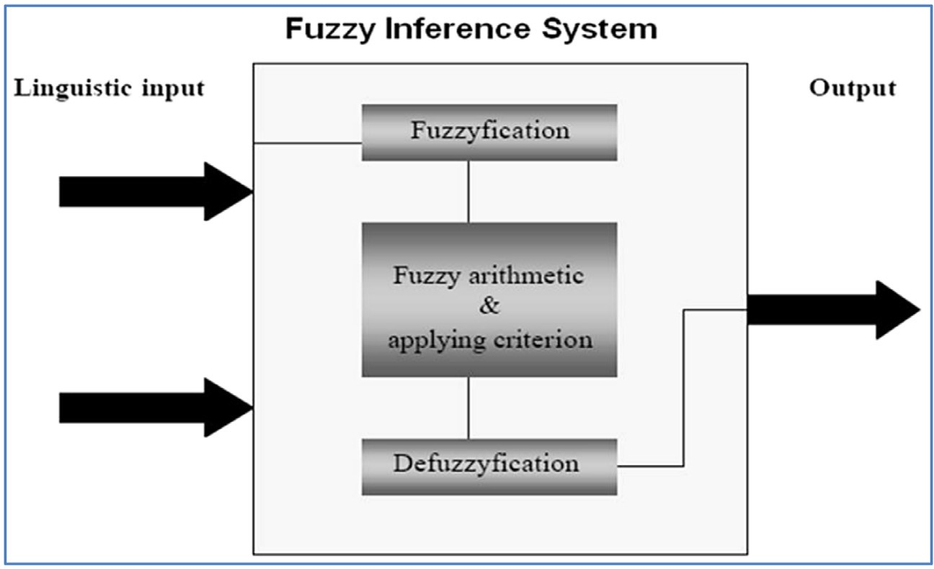**Fig. 2.** Fuzzy Inference system[35].

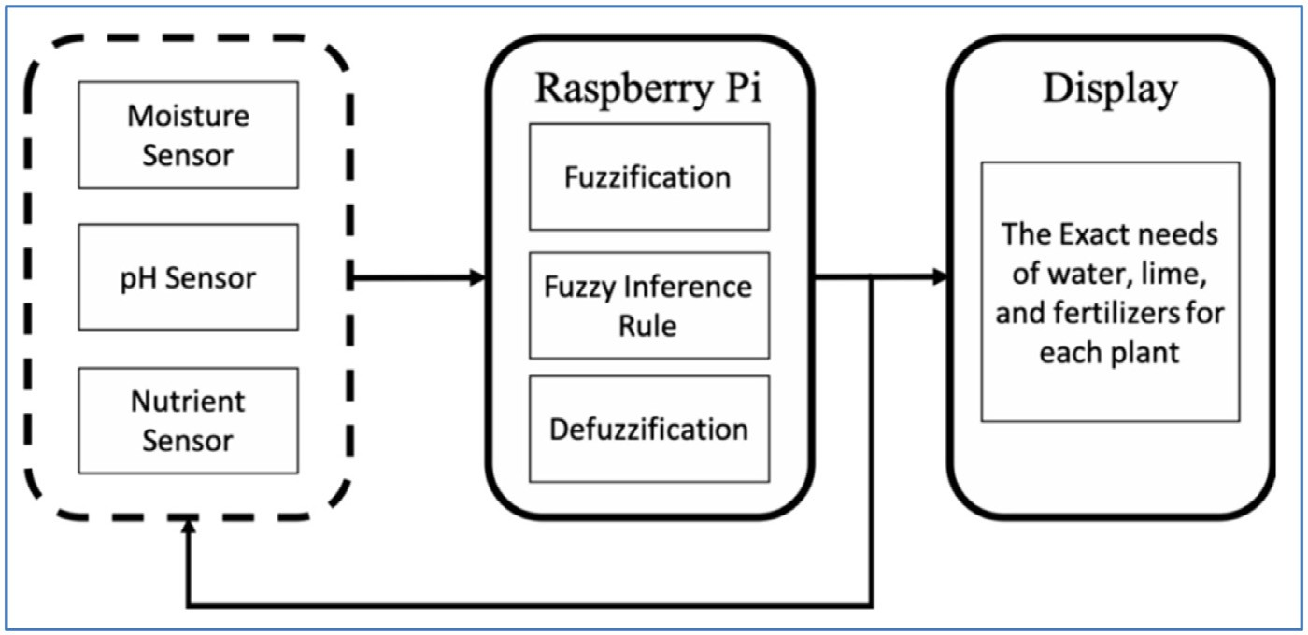**Fig. 3.** FL crop needs recommendations system[38].

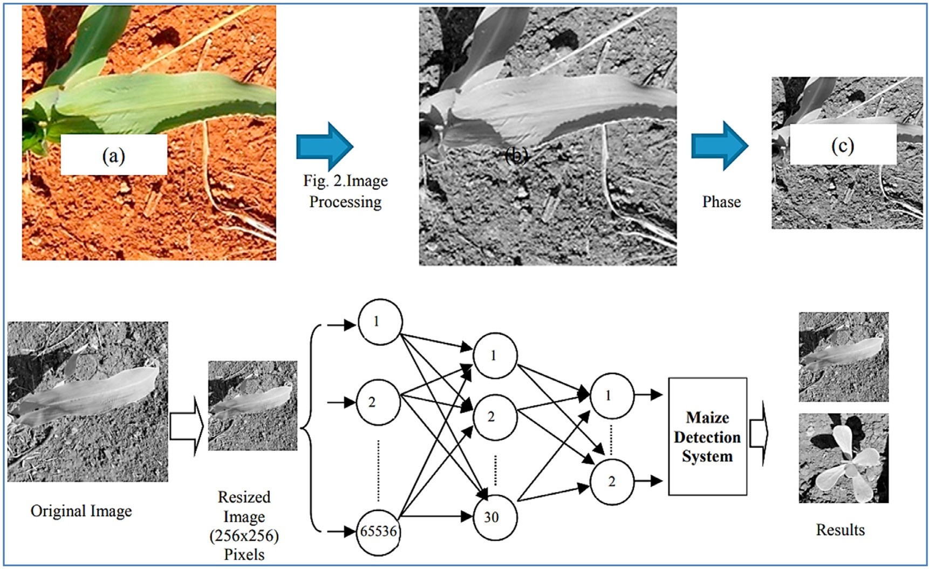

**Fig. 4.** Neural Network Topology of Maize Detection System[45].

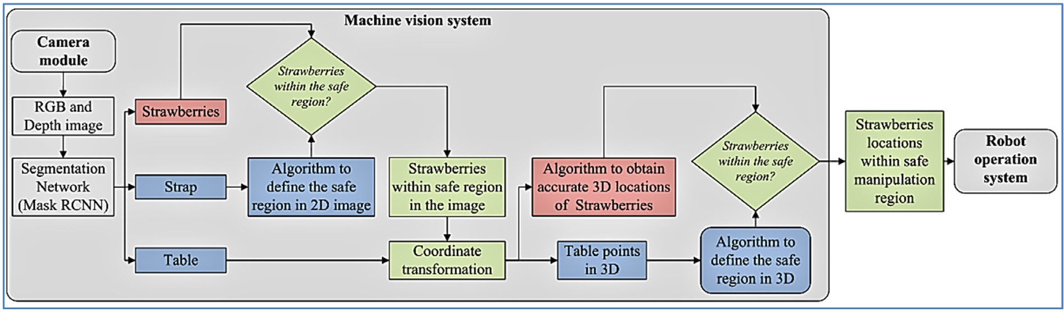

**Fig. 5.** Architecture diagram for strawberries location finding[55].

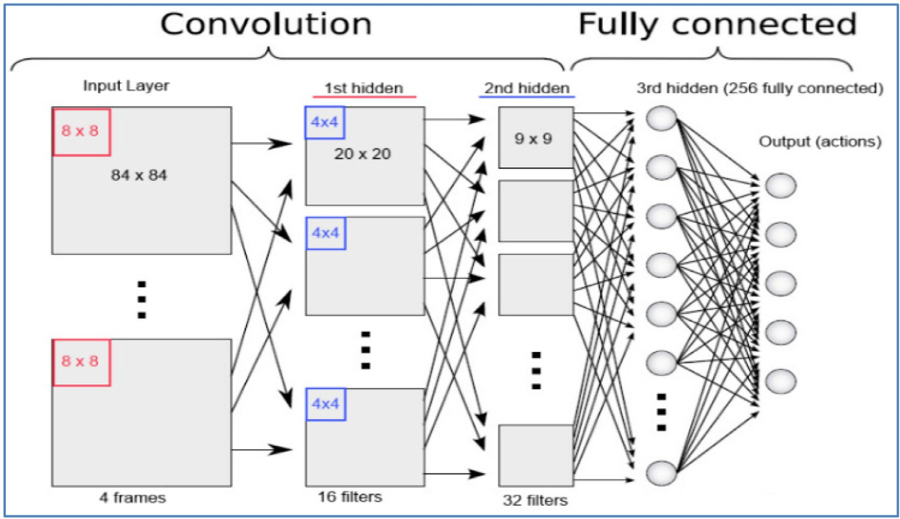**Fig. 6.** CNN classification model[59].

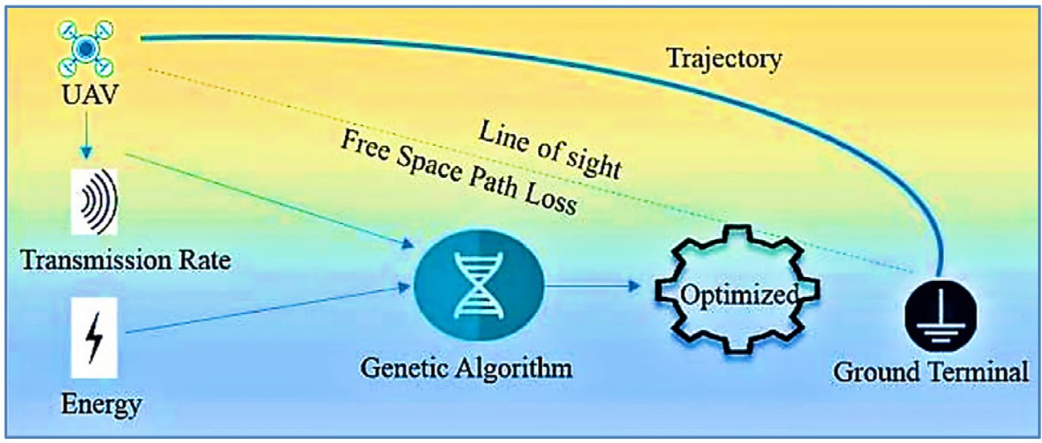

**Fig. 7.** GA optimized UAV trajectory planning[76].

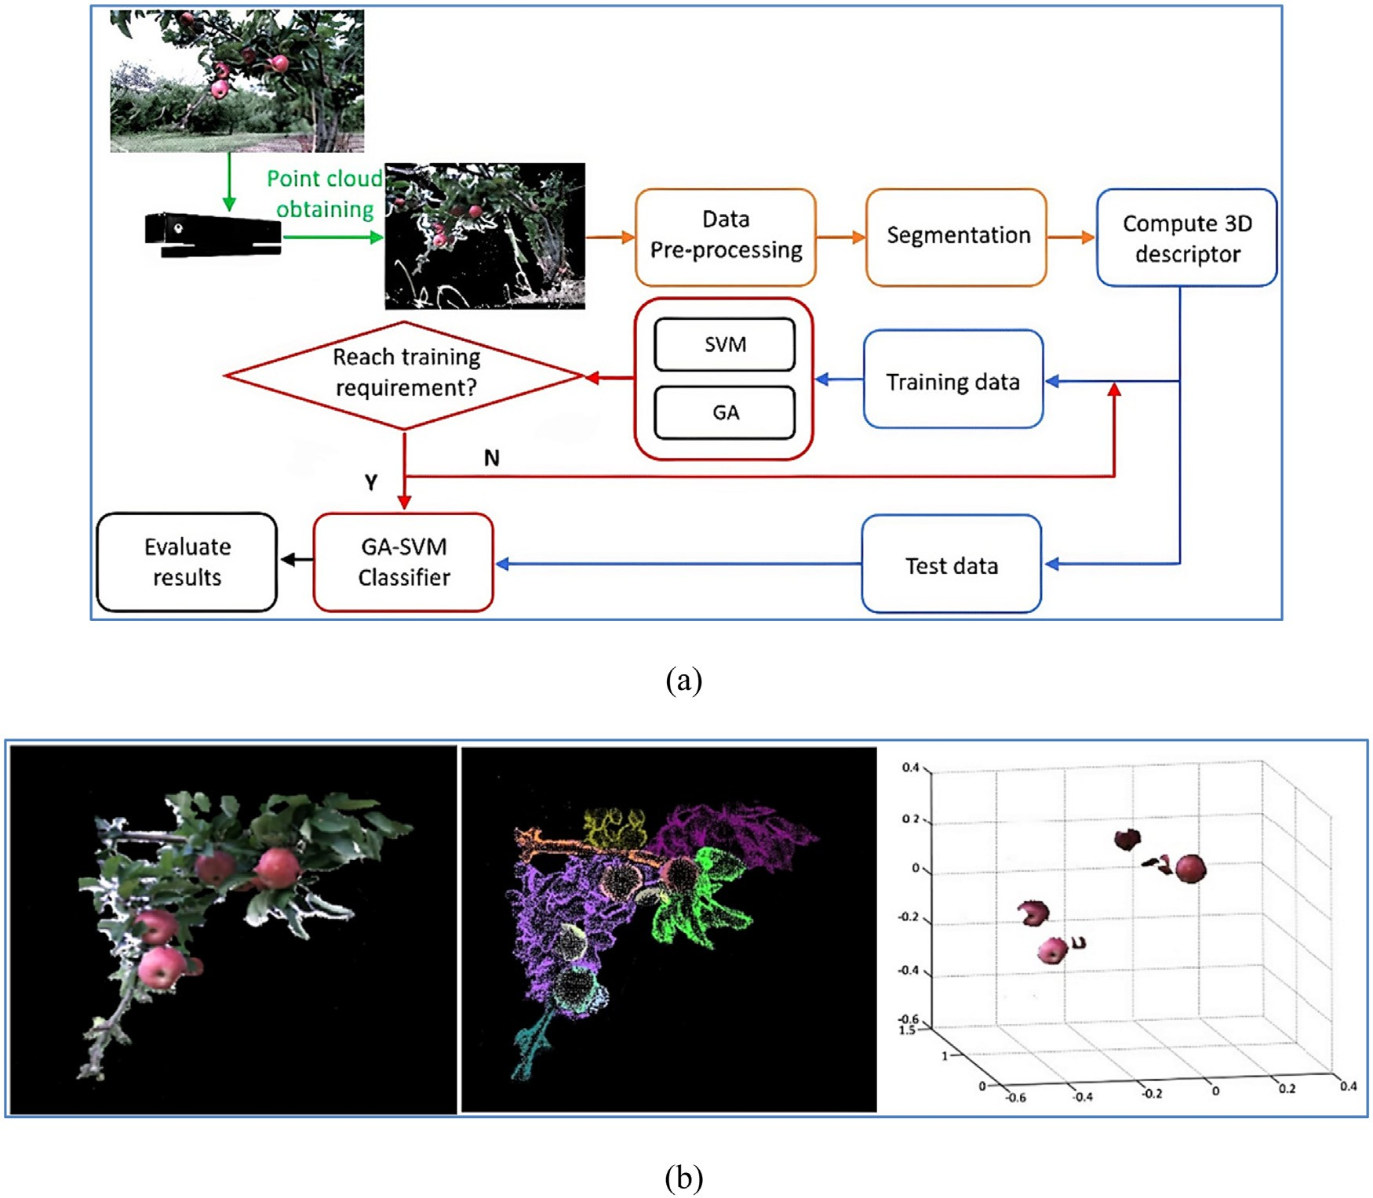

**Fig. 8.** (a) Flowchart for apple recognition and (b) segmentation steps using GA[84].

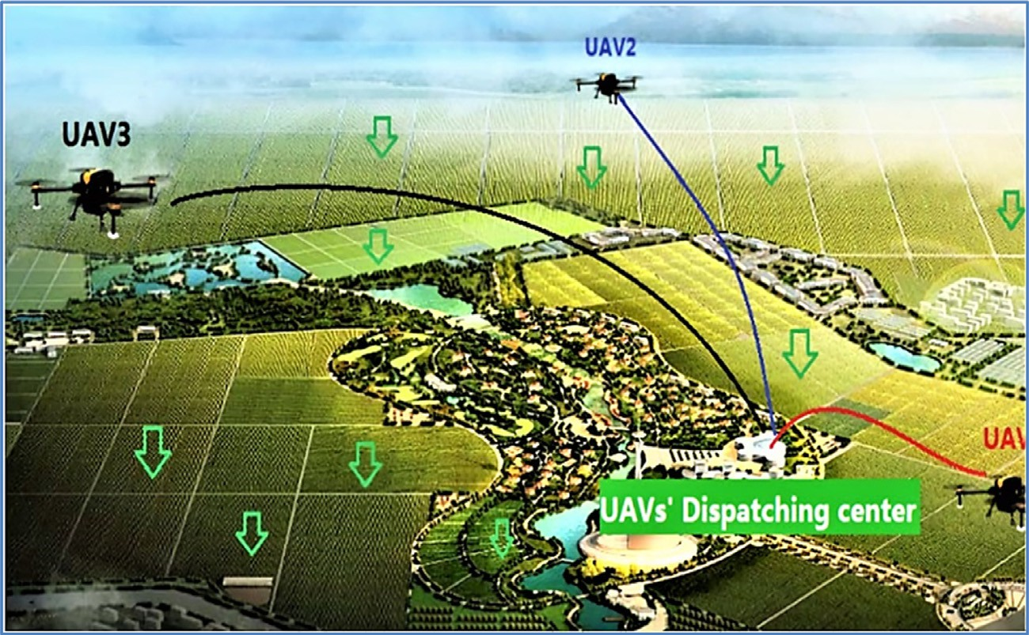

**Fig. 9.** Multiple UAV working scenarios[90].

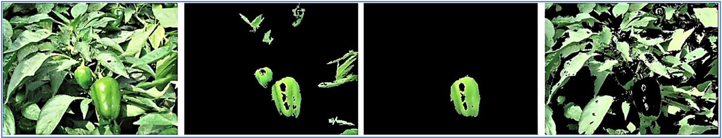

**Fig. 10.** PSO optimizes K-Means segmentation results of green pepper images[96].

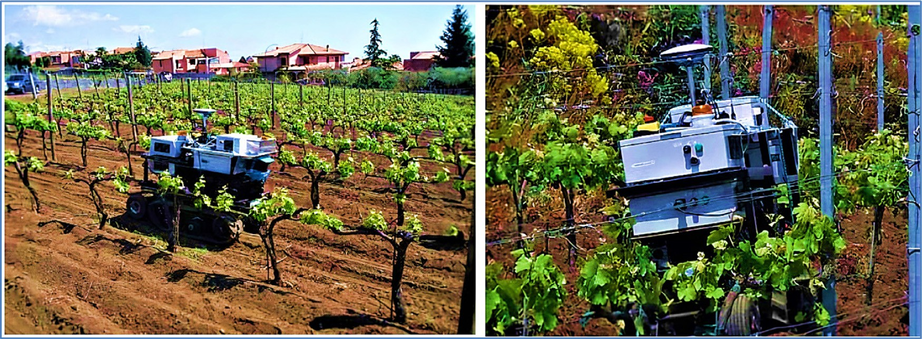

**Fig. 11.** U-Go Robot test on the vineyard[102].

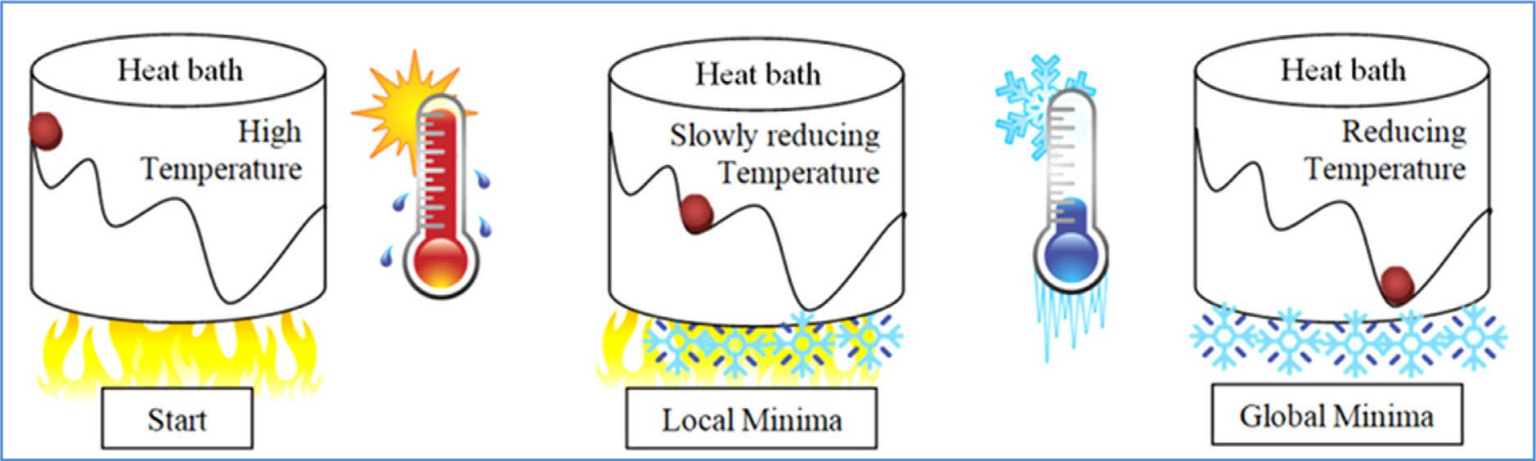

**Fig. 12.** Working of SA.

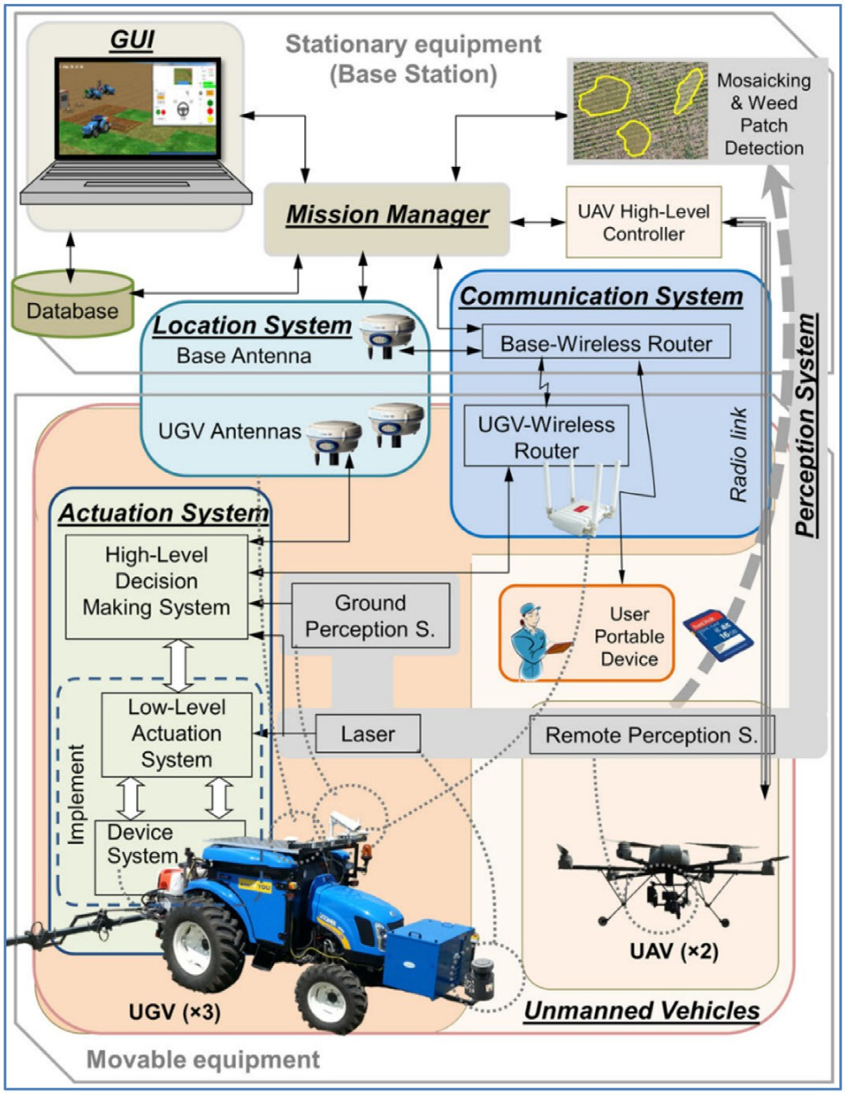

**Fig. 13.** RHEA system architecture using SA[117].

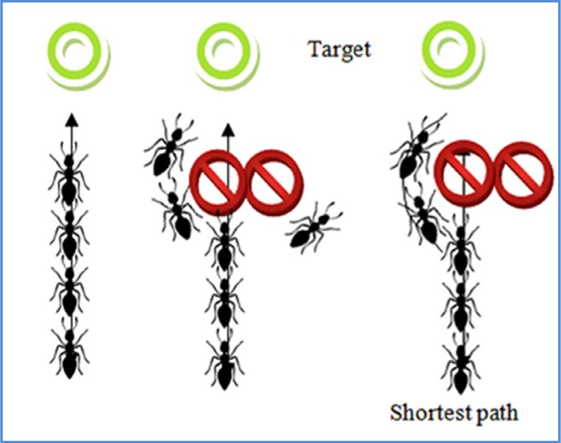

**Fig. 14.** ACO mechanism.

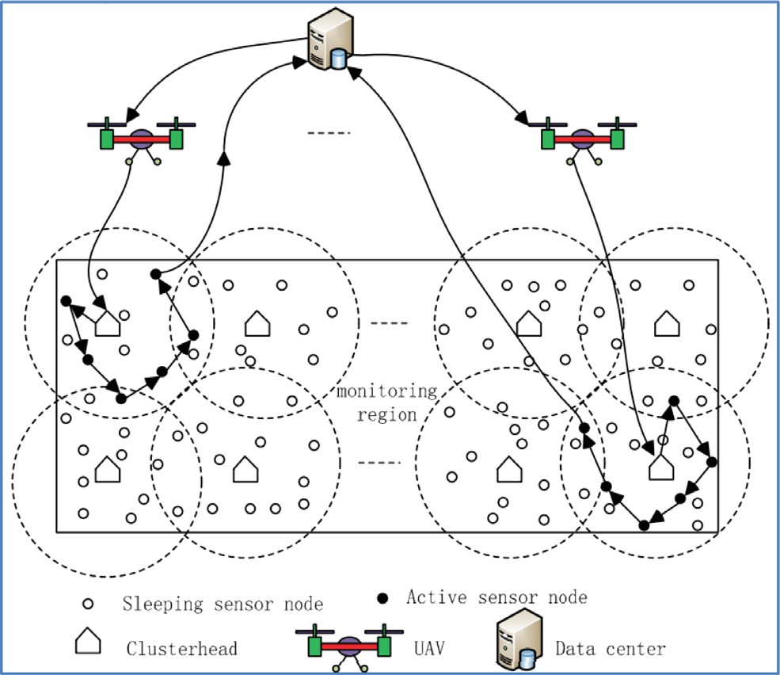

**Fig. 15.** System structure for farmland monitoring using ACO[127].

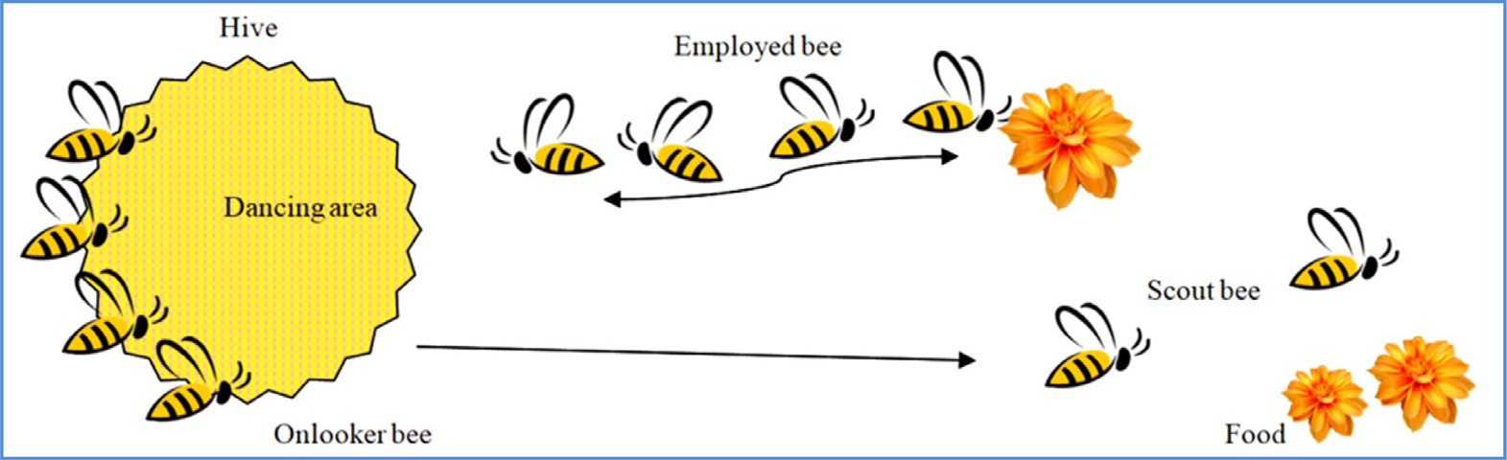

**Fig. 16.** ABC algorithm working mechanism.

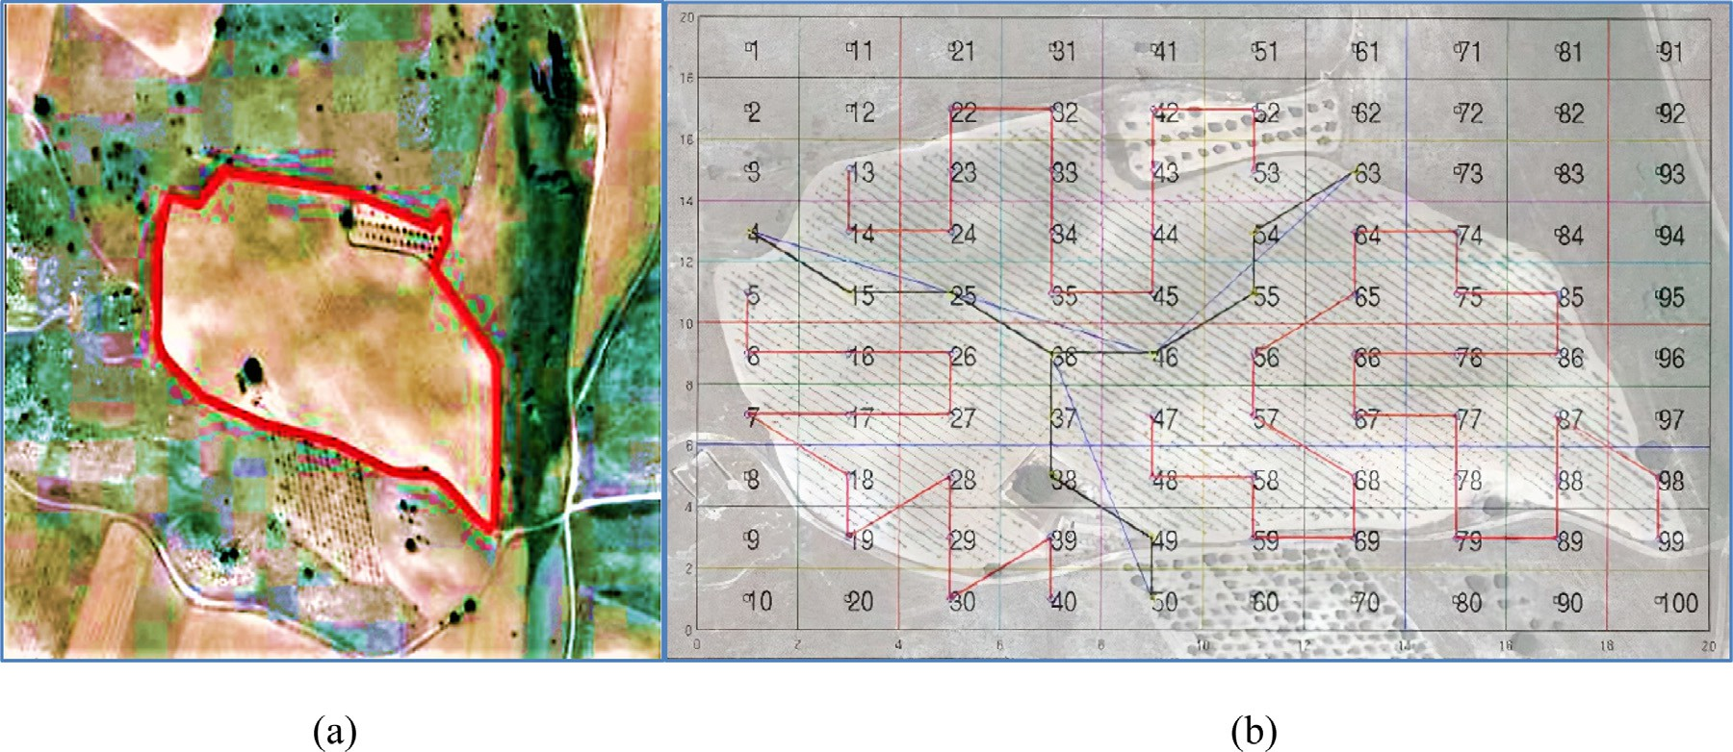

**Fig. 17.** (a) Orthophoto of the vineyard parcel and landscape (b) Coverage trajectories obtained using three quadrotors [139].

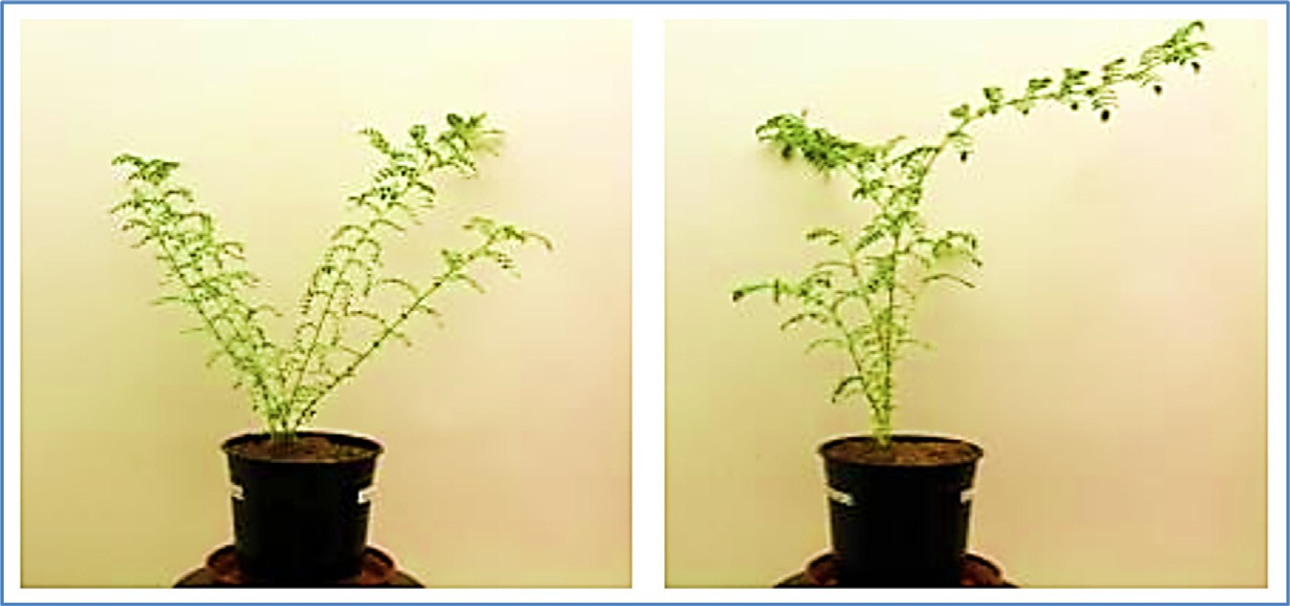

**Fig. 18.** (a) Water stress-tolerant plant (left) and the stress-sensitive plant (right) [145].

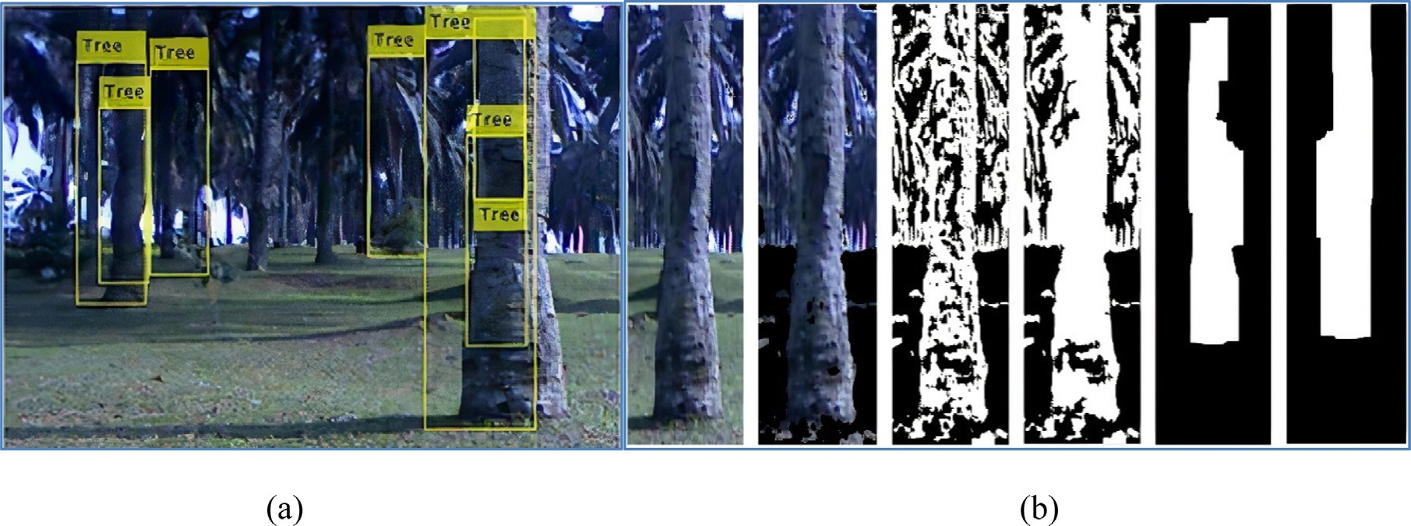

**Fig. 19.** Output (a) and process (b) of the tree detection algorithm [149].

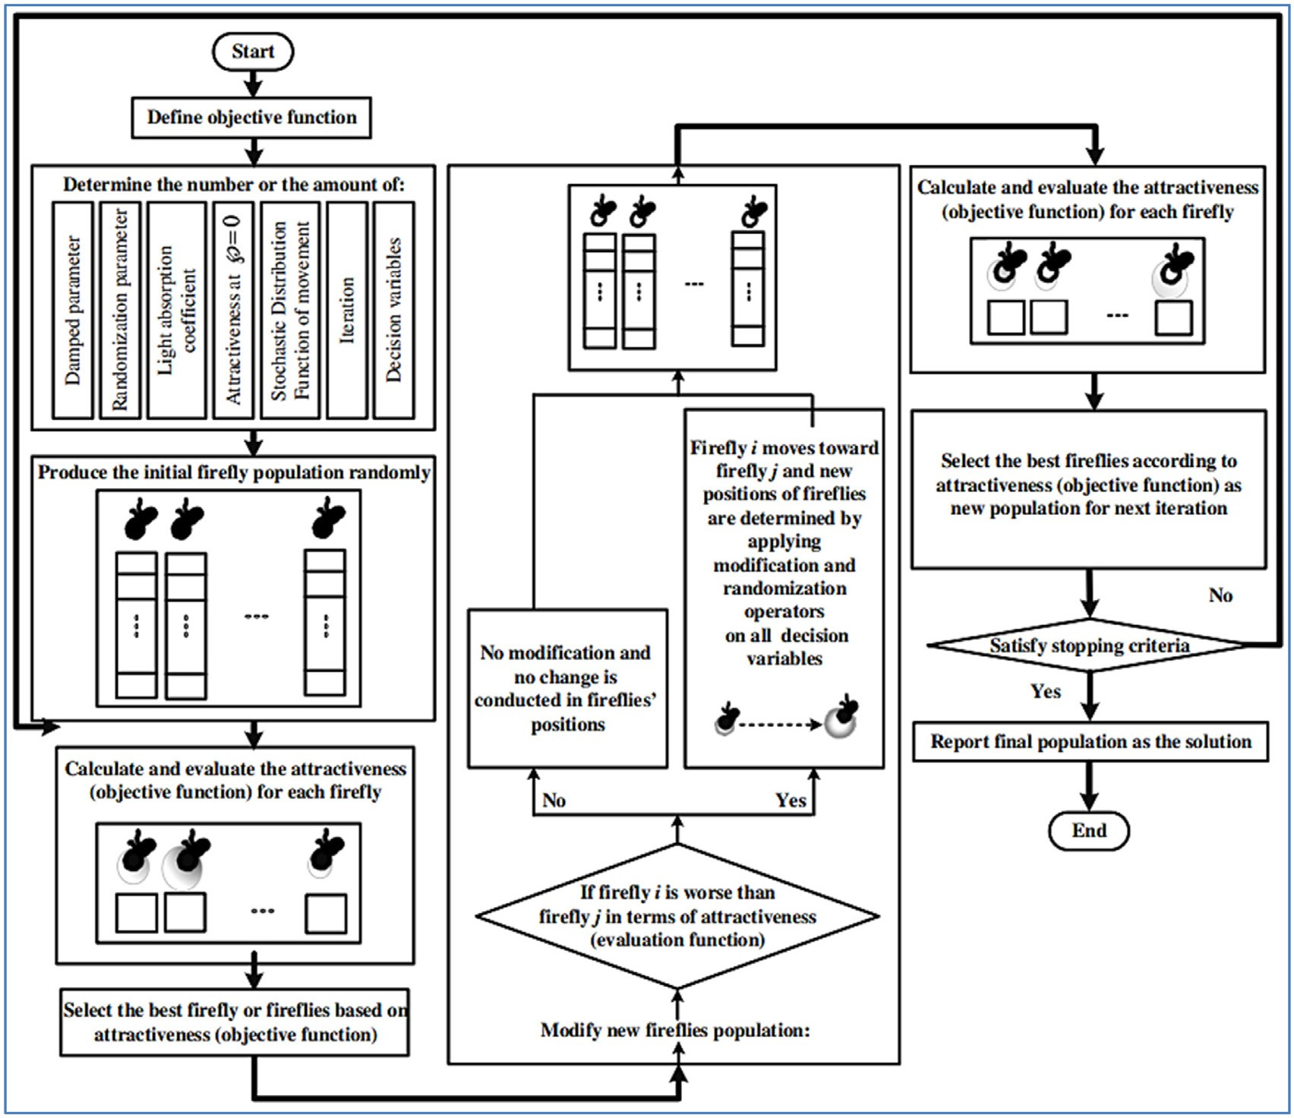

**Fig. 20.** Flowchart of the firefly algorithm as an optimization tool [155].

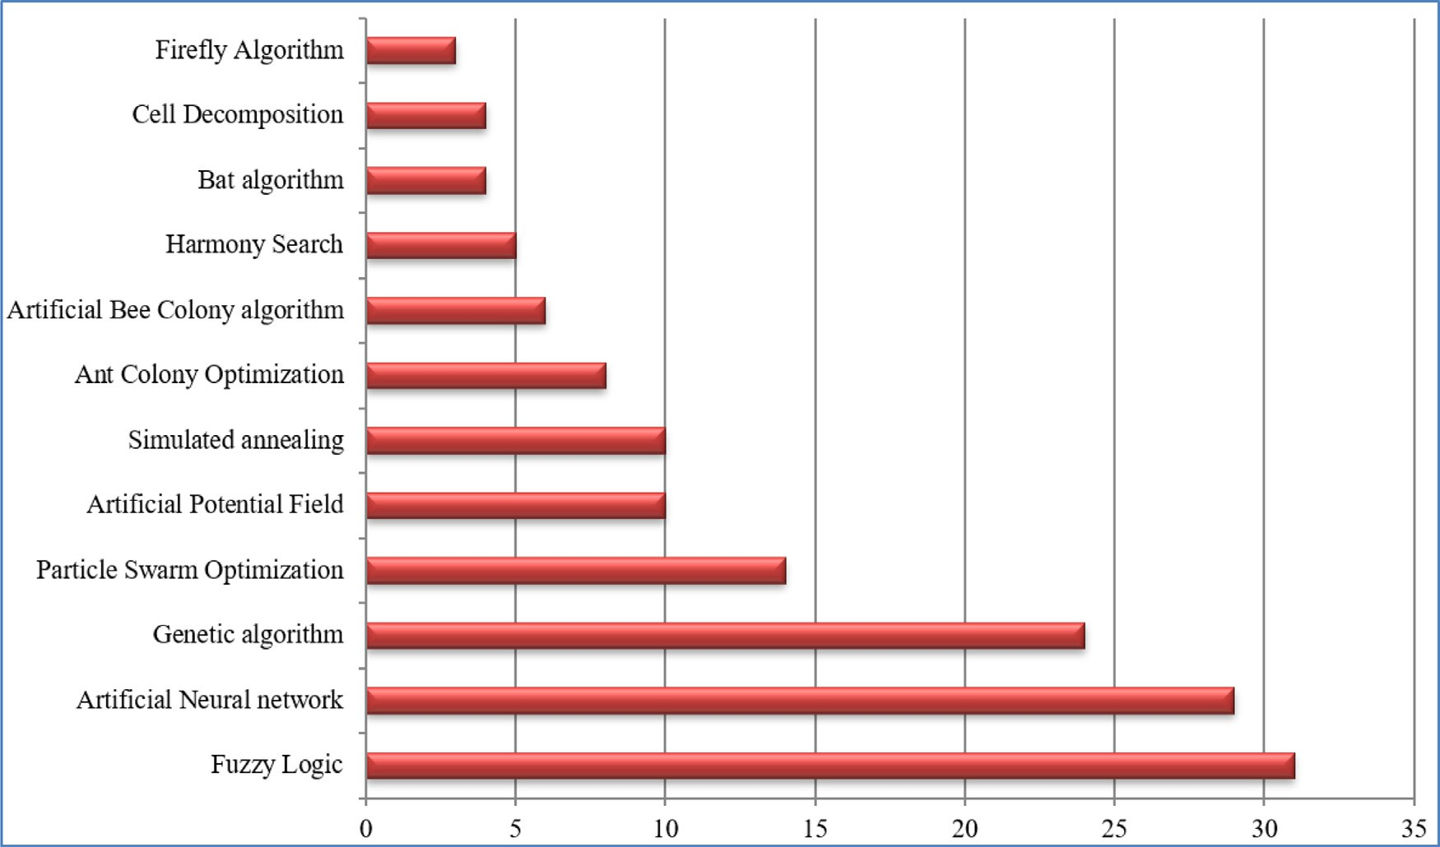

**Fig. 21.** Papers available in the agriculture field using AI.

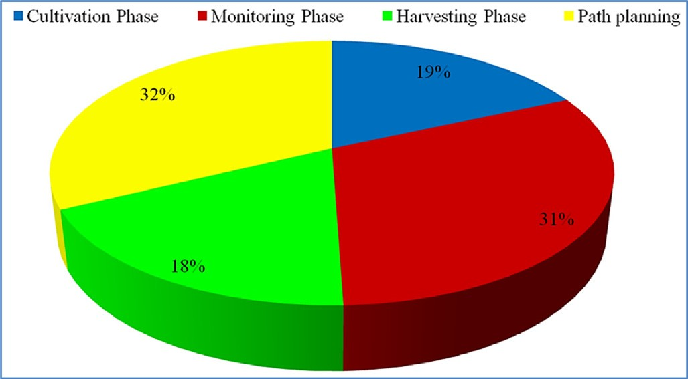 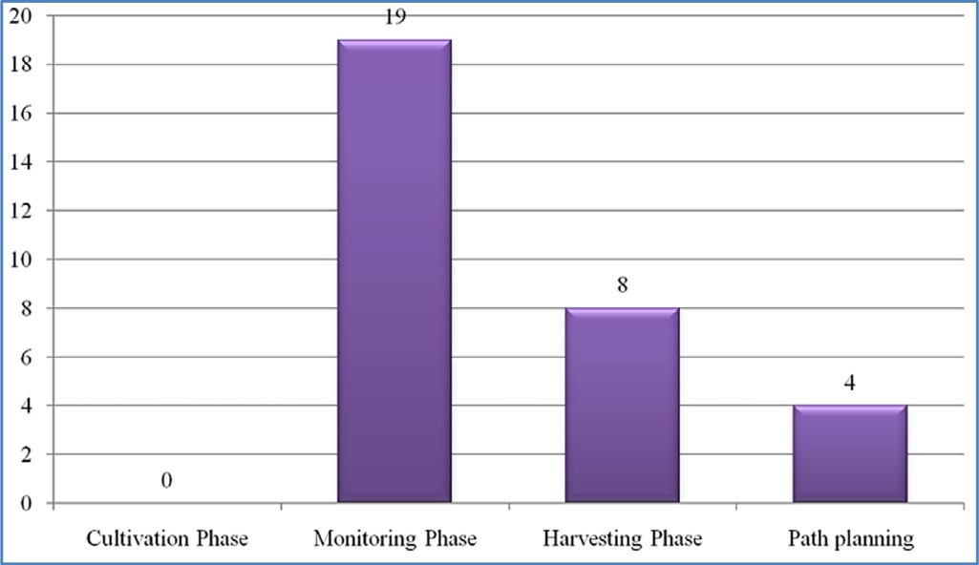

**Fig. 22.** Papers available on various phases of agriculture.

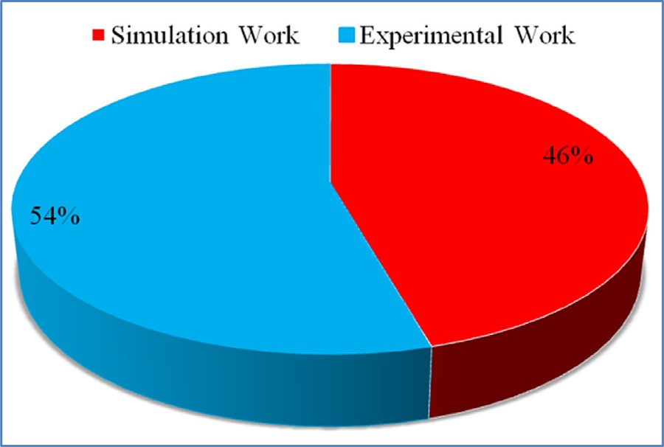

**Fig. 23.** Simulation analysis versus experimental analysis.

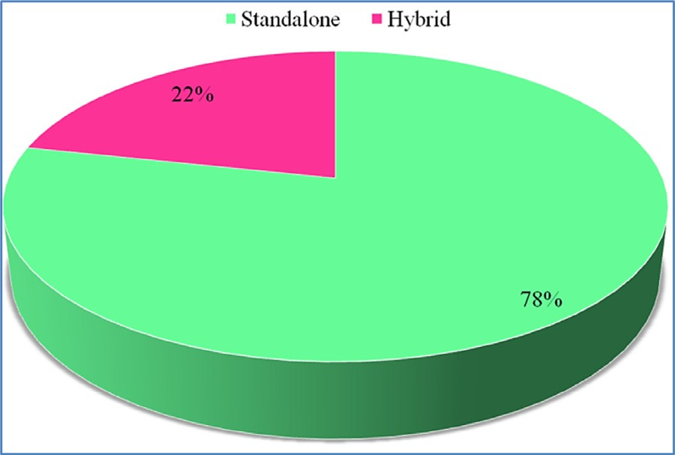

**Fig. 24.** Standalone approaches versus hybrid approaches.

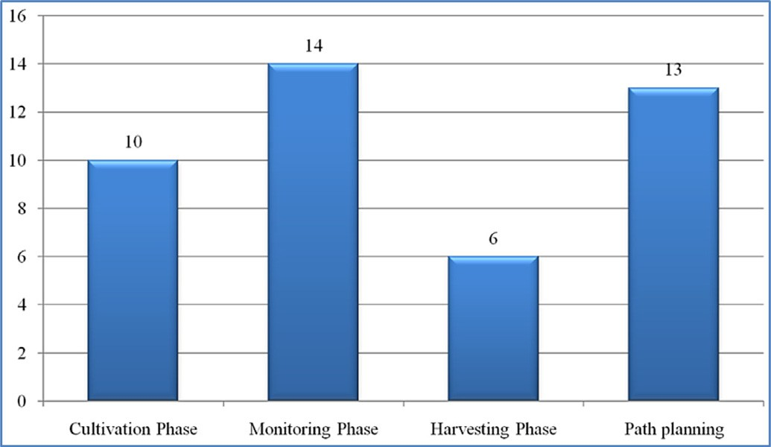

**Fig. 25.** Papers available on fuzzy logic.

**Fig. 26.** Papers available on neural network.

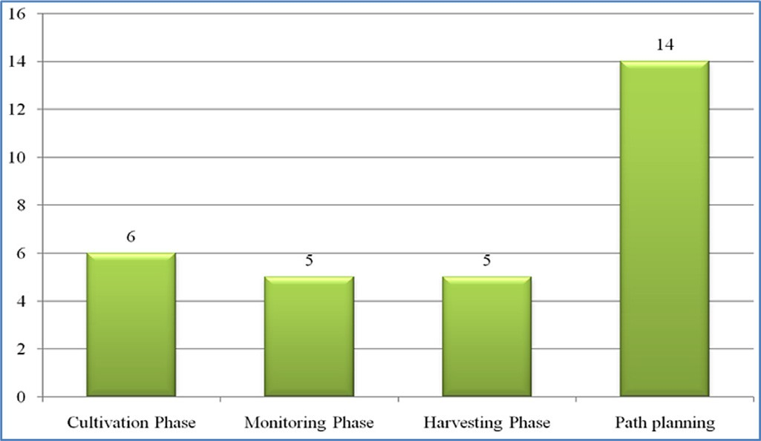

**Fig. 27.** Papers available on genetic algorithm.

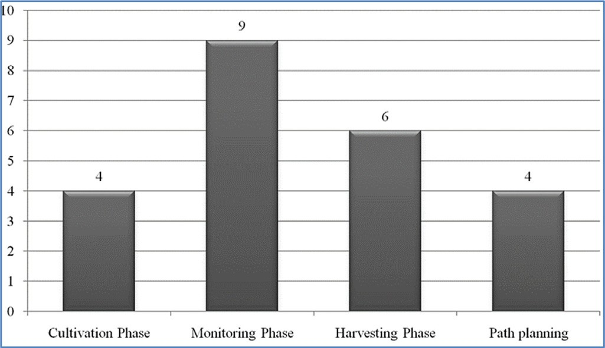

**Fig. 28.** Papers available particle swarm optimization.

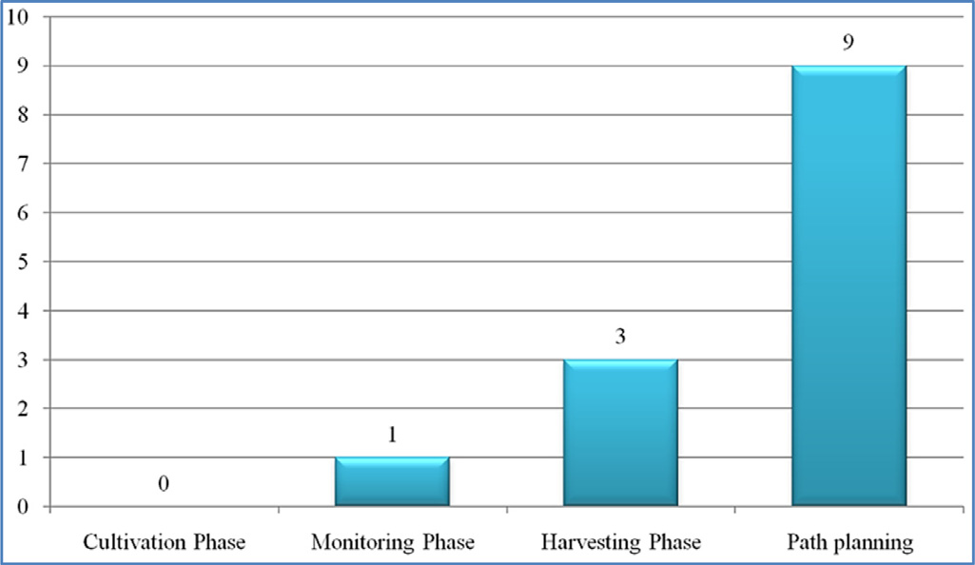

**Fig. 29.** Papers available on the artificial potential field.

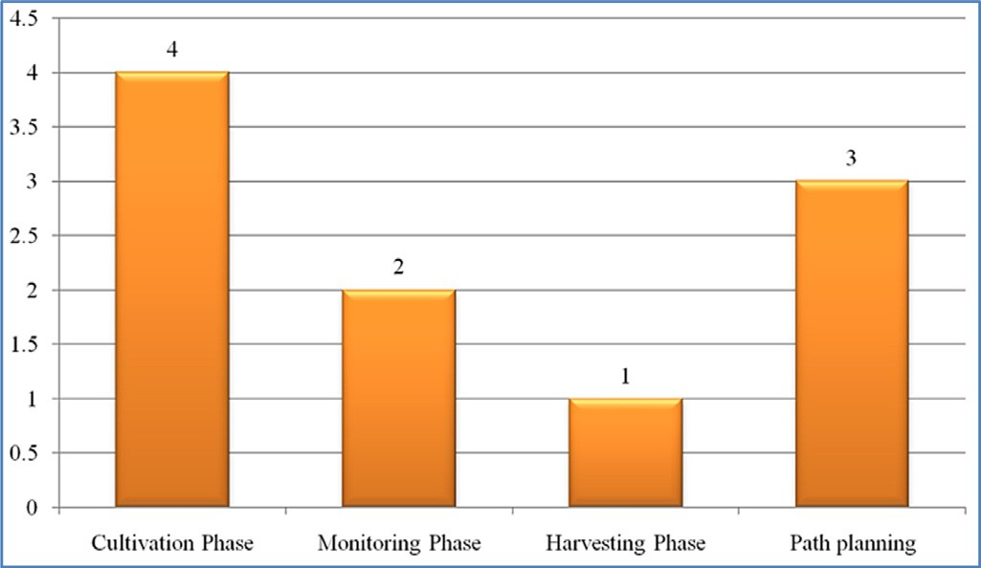 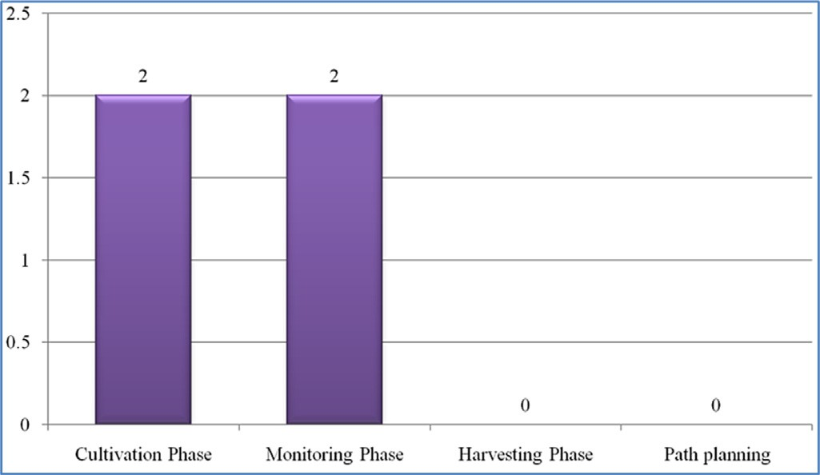

**Fig. 30.** Papers available on simulated annealing.

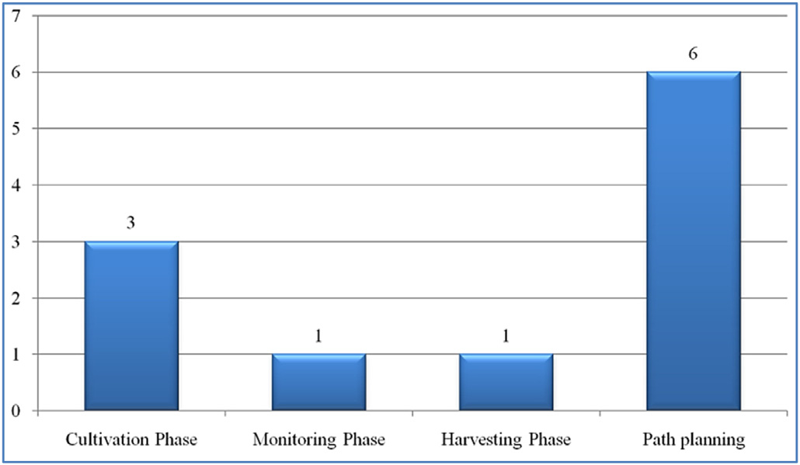

**Fig. 31.** Papers available ant colony optimization.

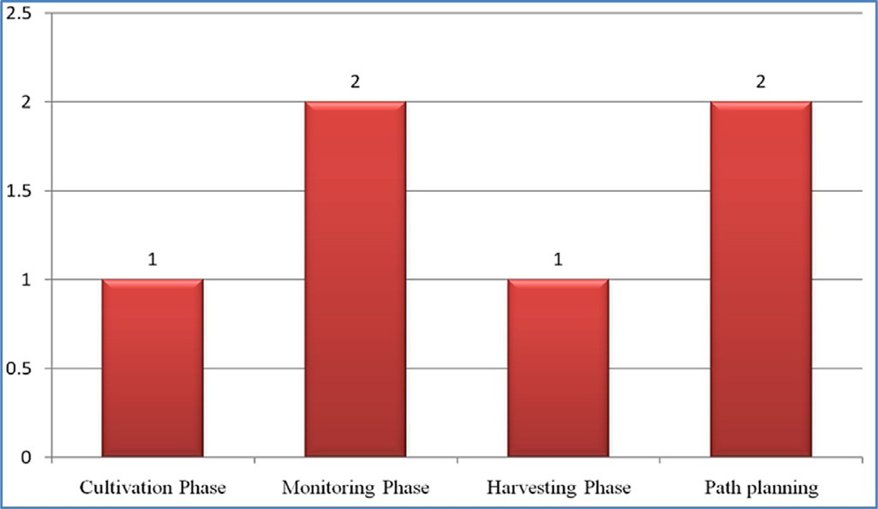

**Fig. 32.** Papers available on artificial bee colony.

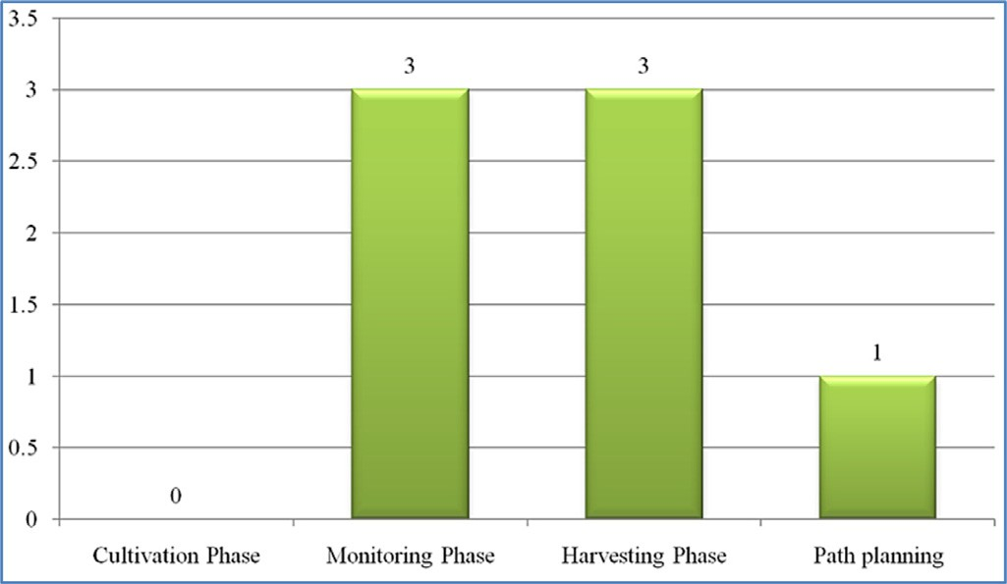

**Fig. 33.** Papers available harmony search.

**Fig. 34.** Papers available on bat algorithm.

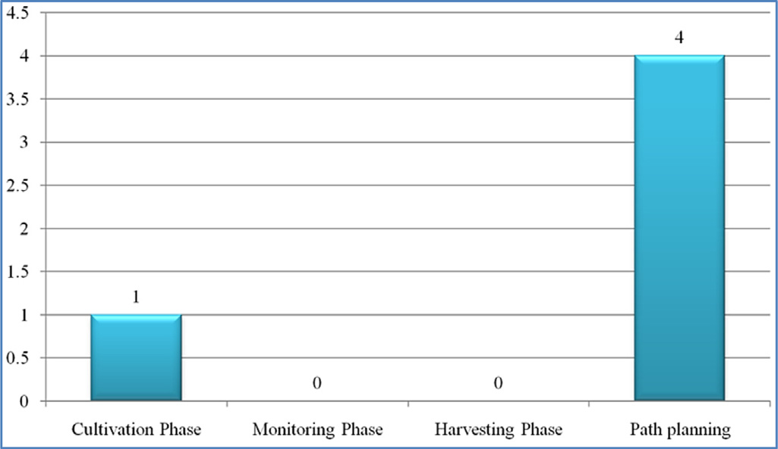

**Fig. 35.** Papers available on cell decomposition.

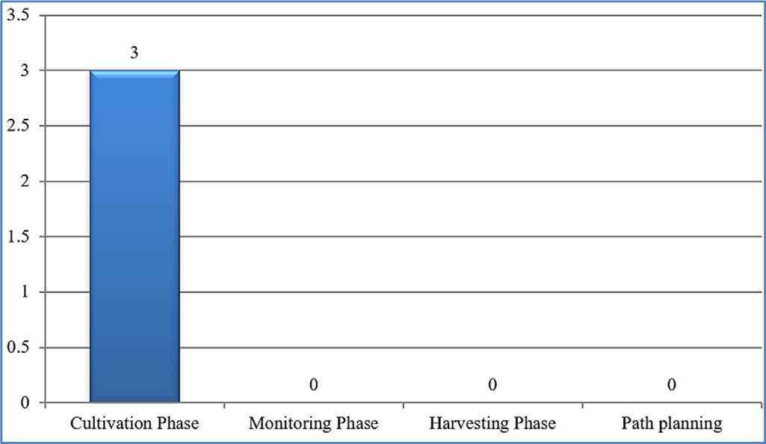

**Fig. 36.** Papers available on the Firefly algorithm.

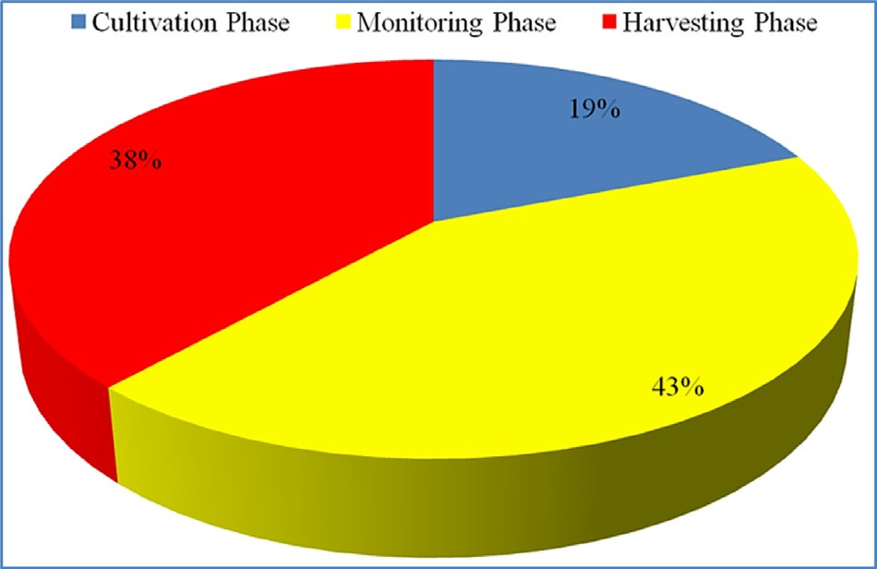

**Fig. 37.** Robots used in each phase.

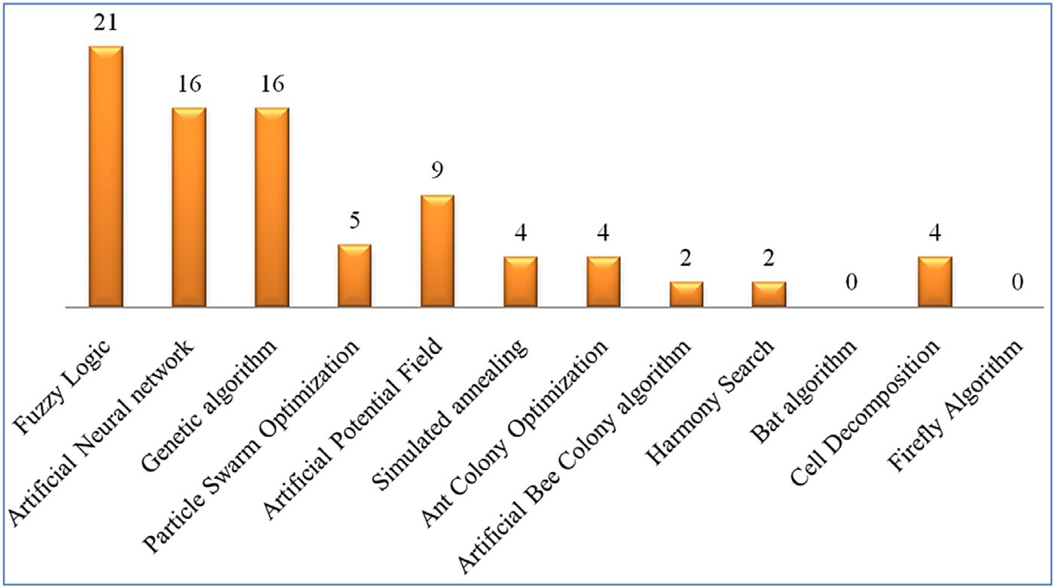**Fig. 38.** Number of papers on AI techniques deployed with Robots.

# Declaration of Competing Interest

The authors whose names are listed immediately below certify that they have NO aﬃliations with or involvement in any organization or en- tity with any financial interest (such as honoraria; educational grants; participation in speakers’ bureaus; membership, employment, consul- tancies, stock ownership, or other equity interest; and expert testimony or patent-licensing arrangements), or non-financial interest (such as per- sonal or professional relationships, aﬃliations, knowledge or beliefs) in the subject matter or materials discussed in this manuscript.

# Data Availability

No data was used for the research described in the article.

# Acknowledgment

The above study and work are not funded and supported by any organization or institute. It is a self-taken initiative.

# References

1. [Mendes JM, Oliveira PM, dos Santos FN, dos Santos RM. Nature inspired meta- heuristics and their applications in agriculture: a short review. In: EPIA Conference on Artificial Intelligence. Cham: Springer; 2019. p. 167–79.](http://refhub.elsevier.com/S2667-3185(23)00001-6/sbref0001)
2. Nielsen Kurt &, Appel Jakob &, Demazeau Yves. Applying AI to cooperating [agricultural robots. IFIP Int Feder Inf Process 2006;204:262–70. doi:10.1007/ 0-387-34224-9_31.](https://doi.org/10.1007/\penalty%20-\%40M%200-387-34224-9_31)
3. [R Shamshiri R, Weltzien C, Hameed IA, J Yule I, E Grift T, Balasundram SK, Chowd- hary G. Research and development in agricultural robotics: a perspective of digital farming; 2018.](http://refhub.elsevier.com/S2667-3185(23)00001-6/sbref0003)
4. [Abdullayeva A. Impact of artificial intelligence on agricultural, healthcare and lo- gistics industries. Ann SpiruHaret Univ Econ Ser 2019;19:167–75.](http://refhub.elsevier.com/S2667-3185(23)00001-6/sbref0004)
5. [Filip M, Zoubek T, Bumbalek R, Cerny P, Batista CE, Olsan P, Findura P. Advanced computational methods for agriculture machinery movement optimization with applications in sugarcane production. Agriculture, 2020;10(10):434.](http://refhub.elsevier.com/S2667-3185(23)00001-6/sbref0005)
6. [Jha K, Doshi A, Patel P, Shah M. A comprehensive review on automation in agri- culture using artificial intelligence. Artif Intell Agric 2019;2:1–12.](http://refhub.elsevier.com/S2667-3185(23)00001-6/sbref0006)
7. [Mousazadeh H. A technical review on navigation systems of agricultural au- tonomous off-road vehicles. J Terramech 2013;50(3):211–32.](http://refhub.elsevier.com/S2667-3185(23)00001-6/sbref0007)
8. [Zadeh LA. Fuzzy sets. Inf Control 1965;8(3):338e53](http://refhub.elsevier.com/S2667-3185(23)00001-6/sbref0008).
9. [Shahjalal M, Alam MZ, Miah SS, Chowdhury AH. Fuzzy logic approach for iden- tifying the effects of climate change on agricultural production. Int J Agric Econ 2021;6(4):181.](http://refhub.elsevier.com/S2667-3185(23)00001-6/sbref0009)
10. [Fujiwara H. Discriminating robot system for carnation seedling with fuzzy logic. IFAC Proc Vol 1991;24(11):231–5.](http://refhub.elsevier.com/S2667-3185(23)00001-6/sbref0010)
11. [Nassiri SM, Tahavoor A, Jafari A. Fuzzy logic classification of mature tomatoes based on physical properties fusion. Inf Process Agric 2021.](http://refhub.elsevier.com/S2667-3185(23)00001-6/sbref0011)
12. [Collewet C, Rault G, Quellec S, Marchal P. Fuzzy adaptive controller design for the joint space control of an agricultural robot. Fuzzy Sets Syst 1998;99(1):1–25.](http://refhub.elsevier.com/S2667-3185(23)00001-6/sbref0012)
13. [Hagras H, Callaghan V, Colley M, Carr-West M. Developing a fuzzy logic controlled agricultural vehicle. In: Third International Conference of Fuzzy Systems and Soft Computing Wiesbaden, Germany; 1998. p. 5–7.](http://refhub.elsevier.com/S2667-3185(23)00001-6/sbref0013)
14. [Hayashi Shigehiko, Ganno Katsunobu, Ishii Yukitsugu. Visual feedback guidance of manipulator for eggplant harvesting using fuzzy logic. J SHITA 2000;12(2):83– 92.](http://refhub.elsevier.com/S2667-3185(23)00001-6/sbref0014)
15. [Cho SI, Chang SJ, Kim YY, An KJ. AE—automation and emerging technologies: development of a three-degrees-of-freedom robot for harvesting lettuce using ma- chine vision and fuzzy logic control. Biosystems Eng 2002;82(2):143–9.](http://refhub.elsevier.com/S2667-3185(23)00001-6/sbref0015)
16. [Xue J, Zhang L, Grift TE. Variable field-of-view machine vision based row guidance of an agricultural robot. Comput Electron Agric 2012;84:85–91.](http://refhub.elsevier.com/S2667-3185(23)00001-6/sbref0016)
17. [Borrero GH, Becker M, Archila JF, Bonito R. Fuzzy control strategy for the adjust- ment of the front steering angle of a 4WSD agricultural mobile robot. In: 2012 7th Colombian Computing Congress (CCC). IEEE; 2012. p. 1–6.](http://refhub.elsevier.com/S2667-3185(23)00001-6/sbref0017)
18. [Kannan P, Natarajan SK, Dash SS. Design and implementation of fuzzy logic con- troller for online computer controlled steering system for navigation of a teleoper- ated agricultural vehicle. Math Probl Eng 2013;2013.](http://refhub.elsevier.com/S2667-3185(23)00001-6/sbref0018)
19. [Barakat MH, Azar AT, Ammar HH. Agricultural service mobile robot modeling and control using artificial fuzzy logic and machine vision. In: International Conference on Advanced Machine Learning Technologies and Applications. Cham: Springer; 2019. p. 453–65.](http://refhub.elsevier.com/S2667-3185(23)00001-6/sbref0019)
20. [De Sousa RV, Tabile RA, Inamasu RY, Porto AJ. A row crop following behavior based on primitive fuzzy behaviors for navigation system of agricultural robots. IFAC Proc Vol 2013;46(18):91–6.](http://refhub.elsevier.com/S2667-3185(23)00001-6/sbref0020)
21. [Toda M, Kitani O, Okamoto T, Torii T. Navigation method for a mobile robot via sonar-based crop row mapping and fuzzy logic control. J Agric Eng Res 1999;72(4):299–309.](http://refhub.elsevier.com/S2667-3185(23)00001-6/sbref0021)
22. [Abdellatif BA. Fuzzy logic based pesticide sprayer for smart agricultural drone. Owner: Girne American University Editor: Asst. Prof. Dr. İbrahim Erşan Advisory Board: Prof. Dr. Sadık‹ lker Assoc. Prof. Dr. ZaferAğdelen Cover Graphic Design: Asst. Prof. Dr. İbrahim Erşan 2015:11.](http://refhub.elsevier.com/S2667-3185(23)00001-6/sbref0022)
23. [Cho SI, Ki NH. Autonomous speed sprayer guidance using machine vision and fuzzy logic. Trans ASAE 1999;42(4):1137–43.](http://refhub.elsevier.com/S2667-3185(23)00001-6/sbref0023)

[on reinforcement learning. NongyeJixieXuebao = Trans Chin Soc Agric Mach](http://refhub.elsevier.com/S2667-3185(23)00001-6/sbref0024) [24] [Zhou J, Chen Q, Liang Q. Vision navigation of agricultural mobile robot based](http://refhub.elsevier.com/S2667-3185(23)00001-6/sbref0024)

[2014;45(2):53–8.](http://refhub.elsevier.com/S2667-3185(23)00001-6/sbref0024)

1. [Narendran V, Edberg CPL, Gandhi GM. Autonomous robot for E-farming based on fuzzy logic reasoning. Int J Pure Appl Math 2018;118(20):3811–21.](http://refhub.elsevier.com/S2667-3185(23)00001-6/sbref0025)
2. [Prema K, Kumar NS, Dash SS, Chowdary S. Online control of remote operated agricultural robot using fuzzy controller and virtual instrumentation. In: IEEE-In- ternational Conference On Advances In Engineering, Science And Management (ICAESM-2012). IEEE; 2012. p. 196–201.](http://refhub.elsevier.com/S2667-3185(23)00001-6/sbref0026)
3. [Paul S, Arunachalam A, Khodadad D, Rubanenko O. Fuzzy tuned PID controller for vibration control of agricultural manipulator. In: 2020 International Congress on Human-Computer Interaction, Optimization and Robotic Applications (HORA). IEEE; 2020. p. 1–5.](http://refhub.elsevier.com/S2667-3185(23)00001-6/sbref0027)
4. [Nderu L, Jouandeau N, Akdag H. Fuzzy Contrast Improvement for Low Altitude Aerial Images. 28th AIII International F Lorida Artificial Intelligence Research So- ciety Conference; 2015.](http://refhub.elsevier.com/S2667-3185(23)00001-6/sbref0028)
5. [Morimoto T, Hashimoto Y. An intelligent control technique based on fuzzy controls, neural networks and genetic algorithms for greenhouse automation. IFAC Proc Vol 1998;31(5):61–6.](http://refhub.elsevier.com/S2667-3185(23)00001-6/sbref0029)
6. [Noguchi N, Reid JF, Zhang Q, Tian LF. Vision intelligence for precision farming us- ing fuzzy logic optimized genetic algorithm and artificial neural network, St Joseph, MI: American Society of Agricultural Engineers; 1998. ASAE paper.](http://refhub.elsevier.com/S2667-3185(23)00001-6/sbref0030)
7. [Hagras H, Callaghan V, Colley M, Carr-West M. A fuzzy-genetic based embedded-a- gent approach to learning and control in agricultural autonomous vehicles. In: Pro- ceedings 1999 IEEE International Conference on Robotics and Automation (Cat. No. 99CH36288C), 2. IEEE; 1999. p. 1005–10.](http://refhub.elsevier.com/S2667-3185(23)00001-6/sbref0031)
8. [Cho SI, Lee JH. Autonomous speed sprayer using differential global positioning system, genetic algorithm, and fuzzy control. J Agric Eng Res 2000;76(2):111– 119.](http://refhub.elsevier.com/S2667-3185(23)00001-6/sbref0032)
9. [Hagras H, Colley M, Callaghan V, Carr-West M. Online learning and adapta- tion of autonomous mobile robots for sustainable agriculture. Auton Robots 2002;13(1):37–52.](http://refhub.elsevier.com/S2667-3185(23)00001-6/sbref0033)
10. [Camci E, Kripalani DR, Ma L, Kayacan E, Khanesar MA. An aerial robot for rice farm quality inspection with type-2 fuzzy neural networks tuned by particle swarm opti- mization-sliding mode control hybrid algorithm. Swarm Evol Comput 2018;41:1–8.](http://refhub.elsevier.com/S2667-3185(23)00001-6/sbref0034)
11. [Upadhya SM, Mathew S. Implementation of fuzzy logic in estimating yield of a vegetable crop. Journal of Physics: Conference Series, 1427. IOP Publishing; 2020.](http://refhub.elsevier.com/S2667-3185(23)00001-6/sbref0035)
12. [Prabakaran G, Vaithiyanathan D, Ganesan M. FPGA based effective agriculture productivity prediction system using fuzzy support vector machine. Math Comput Simul 2021;185:1–16.](http://refhub.elsevier.com/S2667-3185(23)00001-6/sbref0036)
13. [Haban JJI, Puno JCV, Bandala AA, Billones RK, Dadios EP, Sybingco E. Soil Fertil- izer Recommendation System using Fuzzy Logic. In: 2020 IEEE Region 10 Confer- ence (TENCON). IEEE; 2020. p. 1171–5.](http://refhub.elsevier.com/S2667-3185(23)00001-6/sbref0037)
14. [Alfin AA, Ginardi RVH. Optimizing the fertility rate of sugarcane crops at precision agriculture using the fuzzy logic method. IPTEK J Technol Sci 2020;31(3):260–8.](http://refhub.elsevier.com/S2667-3185(23)00001-6/sbref0038)
15. [Puspaningrum A, Ismantohadi E, Sumarudin A. Irrigation forecasting by using fuzzy logic on sensor data. IOP Conference Series: Materials Science and Engineer- ing, 1098. IOP Publishing; 2021.](http://refhub.elsevier.com/S2667-3185(23)00001-6/sbref0039)
16. [Elizondo DA, McClendon RW, Hoogenboom G. Neural network models for predicting flowering and physiological maturity of soybean. Trans ASAE 1994;37(3):981–8.](http://refhub.elsevier.com/S2667-3185(23)00001-6/sbref0040)
17. [Dyrmann M, Karstoft H, Midtiby HS. Plant species classification using deep convo- lutional neural network. Biosystems Eng 2016;151:72–80.](http://refhub.elsevier.com/S2667-3185(23)00001-6/sbref0041)
18. [Behroozi-Khazaei N, Maleki MR. A robust algorithm based on color features for grape cluster segmentation. Comput Electron Agric 2017;142:41–9.](http://refhub.elsevier.com/S2667-3185(23)00001-6/sbref0042)
19. [Liang Q, Long J, Zhu W, Wang Y, Sun W. Apple recognition based on Convolutional Neural Network Framework. In: 2018 13th World Congress on Intelligent Control and Automation (WCICA). IEEE; 2018. p. 1751–6.](http://refhub.elsevier.com/S2667-3185(23)00001-6/sbref0043)
20. [Kumar RA, Rajpurohit VS, Nargund VB. A neural network assisted machine vision system for sorting pomegranate fruits. In: 2017 S International Conference on Elec- trical, Computer and Communication Technologies (ICECCT). IEEE; 2017. p. 1–9.](http://refhub.elsevier.com/S2667-3185(23)00001-6/sbref0044)
21. [Dimililer K, Kiani E. Application of back propagation neural networks on maize plant detection. Procedia Comput Sci 2017;120:376–81.](http://refhub.elsevier.com/S2667-3185(23)00001-6/sbref0045)
22. [Thuyet DQ, Kobayashi Y, Matsuo M. A robot system equipped with deep convolu- tional neural network for autonomous grading and sorting of root-trimmed garlics. Comput Electron Agric 2020;178:105727.](http://refhub.elsevier.com/S2667-3185(23)00001-6/sbref0046)
23. [Zhao B, Zhu ZX, Mao ER, Song ZH. Vision system calibration of agricul- tural wheeled-mobile robot based on BP neural network. In: 2007 Interna- tional Conference on Machine Learning and Cybernetics, 1. IEEE; 2007. p. 340– 344.](http://refhub.elsevier.com/S2667-3185(23)00001-6/sbref0047)
24. [Tang J, Jing X, He D, David F. Visual navigation control for agricultural robot using serial BP neural network. Trans Chin Soc Agric Eng 2011;27(2):194–8.](http://refhub.elsevier.com/S2667-3185(23)00001-6/sbref0048)
25. [Dorrer MG, Popov AA, Tolmacheva AE. Building an artificial vision system of an agricultural robot based on the Dark Net system. IOP Conference Series: Earth and Environmental Science, 548. IOP Publishing; 2020.](http://refhub.elsevier.com/S2667-3185(23)00001-6/sbref0049)
26. [Hall D, Dayoub F, Kulk J, McCool C. Towards unsupervised weed scouting for agricultural robotics. In: 2017 IEEE International Conference on Robotics and Au- tomation (ICRA). IEEE; 2017. p. 5223–30.](http://refhub.elsevier.com/S2667-3185(23)00001-6/sbref0050)
27. [McCool C, Perez T, Upcroft B. Mixtures of lightweight deep convolutional neural networks: applied to agricultural robotics. IEEE Robot Autom Lett 2017;2(3):1344–51.](http://refhub.elsevier.com/S2667-3185(23)00001-6/sbref0051)
28. [Champ J, Mora Fallas A, Goëau H, Mata Montero E, Bonnet P, Joly A. Instance seg- mentation for the fine detection of crop and weed plants by precision agricultural robots. Appl Plant Sci 2020;8(7):e11373.](http://refhub.elsevier.com/S2667-3185(23)00001-6/sbref0052)
29. [.. & Sa I, Popovic M, Khanna R, Chen Z, Lottes P, Liebisch F, Siegwart R. Weedmap: a large-scale semantic weed mapping framework using aerial multispec- tral imaging and deep neural network for precision farming. Remote Sens (Basel) 2018;10(9):1423.](http://refhub.elsevier.com/S2667-3185(23)00001-6/sbref0053)
30. [Habaragamuwa H, Ogawa Y, Suzuki T, Shiigi T, Ono M, Kondo N. Detecting green- house strawberries (mature and immature), using deep convolutional neural net- work. Eng Agric Environ Food 2018;11(3):127–38.](http://refhub.elsevier.com/S2667-3185(23)00001-6/sbref0054)
31. [Ge Y, Xiong Y, Tenorio GL, From PJ. Fruit localization and environment perception for strawberry harvesting robots. IEEE Access 2019;7:147642–52.](http://refhub.elsevier.com/S2667-3185(23)00001-6/sbref0055)
32. [Lulio LC, Tronco ML, Porto AJ. JSEG-based image segmentation in computer vision for agricultural mobile robot navigation. In: 2009 IEEE International Symposium on Computational Intelligence in Robotics and Automation-(CIRA). IEEE; 2009.](http://refhub.elsevier.com/S2667-3185(23)00001-6/sbref0056)

[p. 240–5.](http://refhub.elsevier.com/S2667-3185(23)00001-6/sbref0056)

1. [Bo Z, Hua MW, He SZ, Rong ME. Path recognition method of agricultural wheeled– mobile robot in shadow environment. In: 2010 International Conference on E-Health Networking Digital Ecosystems and Technologies (EDT), 1. IEEE; 2010.](http://refhub.elsevier.com/S2667-3185(23)00001-6/sbref0057)

[p. 284–7.](http://refhub.elsevier.com/S2667-3185(23)00001-6/sbref0057)

1. [Xenakis A, Papastergiou G, Gerogiannis VC, Stamoulis G. Applying a Convolutional Neural Network in an IoT Robotic System for Plant Disease Diagnosis. In: 2020 11th International Conference on Information, Intelligence, Systems and Applications (IISA. IEEE; 2020. p. 1–8.](http://refhub.elsevier.com/S2667-3185(23)00001-6/sbref0058)
2. [Sharmila VC, Chauhan N, Kumar R, Barwal SK. Design of intelligent insect moni- toring system using deep learning techniques; 2021.](http://refhub.elsevier.com/S2667-3185(23)00001-6/sbref0059)
3. [Singh K, Rawat R, Ashu A. Image segmentation in agriculture crop and weed de- tection using image processing and deep learning techniques. Int J Res Eng Sci Manage 2021;4(5):235–8.](http://refhub.elsevier.com/S2667-3185(23)00001-6/sbref0060)
4. [Mary MF, Yogaraman D. Neural network based weeding robot for crop and weed discrimination. Journal of Physics: Conference Series, 1979. IOP Publishing; 2021.](http://refhub.elsevier.com/S2667-3185(23)00001-6/sbref0061)
5. [Guillén-Navarro MA, Martínez-España R, Llanes A, Bueno-Crespo A, Cecilia JM. A deep learning model to predict lower temperatures in agriculture. J Ambient Intell Smart Environ 2020;12(1):21–34.](http://refhub.elsevier.com/S2667-3185(23)00001-6/sbref0062)
6. [Mhango JK, Harris EW, Green R, Monaghan JM. Mapping potato plant density vari- ation using aerial imagery and deep learning techniques for precision agriculture. Remote Sens (Basel) 2021;13(14):2705.](http://refhub.elsevier.com/S2667-3185(23)00001-6/sbref0063)
7. [Khan S, Tufail M, Khan MT, Khan ZA, Anwar S. Deep-learning-based spraying area recognition system for unmanned-aerial-vehicle-based sprayers. Turkish J Electr Eng Comput Sci 2021;29(1).](http://refhub.elsevier.com/S2667-3185(23)00001-6/sbref0064)
8. [Munir K, Umar AI, Yousaf W. Automatic fruits classification system based on deep neural network. NUST J Eng Sci 2020;13(1):37–44.](http://refhub.elsevier.com/S2667-3185(23)00001-6/sbref0065)
9. J.H. Holland, “Adaptation in natural and artificial systems. Ann Aebor,” MI: Uni- versity of Michigan Press.
10. [Makino T, Yokoi H, Kakazu Y. Development of a motion planning system for an agricultural mobile robot. In: SICE’99. Proceedings of the 38th SICE Annual Conference. International Session Papers (IEEE Cat. No. 99TH8456). IEEE; 1999.](http://refhub.elsevier.com/S2667-3185(23)00001-6/sbref0067)

[p. 959–62.](http://refhub.elsevier.com/S2667-3185(23)00001-6/sbref0067)

1. [Dohi M, Fujiura T, Ishizuka N, Nonami K. Gait control by genetic algorithm for agricultural hexapod walking robot. IFAC Proc Vol 2000;33(29):89–93.](http://refhub.elsevier.com/S2667-3185(23)00001-6/sbref0068)
2. [Ferentinos KP, Arvanitis KG, Sigrimis N. Heuristic optimization methods for motion planning of autonomous agricultural vehicles. J Global Optim 2002;23(2):155–70.](http://refhub.elsevier.com/S2667-3185(23)00001-6/sbref0069)
3. [Ryerson AF, Zhang Q. Vehicle path planning for complete field coverage using genetic algorithms. Agric Eng Int: CIGR J 2007.](http://refhub.elsevier.com/S2667-3185(23)00001-6/sbref0070)
4. [Jihong M. Path planning design of seeding machine based on artificial force field and genetic algorithm. J Agric Mechaniz Res 2016;7:41.](http://refhub.elsevier.com/S2667-3185(23)00001-6/sbref0071)
5. [Pham TH, Bestaoui Y, Mammar S. Aerial robot coverage path planning approach with concave obstacles in precision agriculture. In: 2017 Workshop on Research, Education and Development of Unmanned Aerial Systems (RED-UAS). IEEE; 2017.](http://refhub.elsevier.com/S2667-3185(23)00001-6/sbref0072)

[p. 43–8.](http://refhub.elsevier.com/S2667-3185(23)00001-6/sbref0072)

1. [Noguchi N, Terao H. Path planning of an agricultural mobile robot by neural net- work and genetic algorithm. Comput Electron Agric 1997;18(2–3):187–204.](http://refhub.elsevier.com/S2667-3185(23)00001-6/sbref0073)
2. [Mahmud MSA, Abidin MSZ, Mohamed Z. Solving an agricultural robot routing problem with binary particle swarm optimization and a genetic algorithm. Int J Mech Eng Robot Res 2018;7(5):521–7.](http://refhub.elsevier.com/S2667-3185(23)00001-6/sbref0074)
3. [Conesa-Muñoz J, Ribeiro A, Andujar D, Fernandez-Quintanilla C, Dorado J. Mul- ti-path planning based on a NSGA-II for a fleet of robots to work on agricultural tasks. In: 2012 IEEE Congress on Evolutionary Computation. IEEE; 2012. p. 1–8.](http://refhub.elsevier.com/S2667-3185(23)00001-6/sbref0075)
4. [Singh R, Chaudhary HR, Dubey AK. Trajectory design for UAV-to-ground commu- nication with energy optimization using genetic algorithm for agriculture applica- tion. IEEE Sens J 2020.](http://refhub.elsevier.com/S2667-3185(23)00001-6/sbref0076)
5. [Shang G, Liu G, Zhu P, Han J. Complete coverage path planning for horticul- tural electric tractors based on an improved genetic algorithm. J Appl Sci Eng 2021;24(3):447–56.](http://refhub.elsevier.com/S2667-3185(23)00001-6/sbref0077)
6. [Gao F, Li Y, Minami M, Huang Y. Visual navigation method based on genetic algo- rithm for agricultural mobile robots. Nongye Jixie Xuebao /Trans Chin Soc Agric Mach 2008;39(6):127–31.](http://refhub.elsevier.com/S2667-3185(23)00001-6/sbref0078)
7. [Meng Q, Hao X, Zhang Y, Yang G. Guidance line identification for agricultural mobile robot based on machine vision. In: 2018 IEEE 3rd Advanced Information Technology, Electronic and Automation Control Conference (IAEAC). IEEE; 2018.](http://refhub.elsevier.com/S2667-3185(23)00001-6/sbref0079)

[p. 1887–93.](http://refhub.elsevier.com/S2667-3185(23)00001-6/sbref0079)

1. [Dacal-Nieto A, Vázquez-Fernández E, Formella A, Martin F, Torres-Guijarro S, González-Jorge H. A genetic algorithm approach for feature selection in potatoes classification by computer vision. In: 2009 35th Annual Conference of IEEE Indus- trial Electronics. IEEE; 2009. p. 1955–60.](http://refhub.elsevier.com/S2667-3185(23)00001-6/sbref0080)
2. [Feng Q, Jiao Z, Junzheng W, Xueqiang M, Zixing G, Dongnian L, Xiaohui H. Genetic algorithm-based optimization of nutrient solution formula for substrate-cultivated cucumber. Trans Chin Soc Agric Eng 2021;37(2).](http://refhub.elsevier.com/S2667-3185(23)00001-6/sbref0081)
3. [Monís JI, López-Luque R, Reca J, Martínez J. Multistage bounded evolutionary al- gorithm to optimize the design of sustainable photovoltaic (PV) pumping irrigation systems with storage. Sustainability 2020;12(3):1026.](http://refhub.elsevier.com/S2667-3185(23)00001-6/sbref0082)
4. [Ahmed NM, Farghally HM, Fahmy FH. Optimal sizing and economical analysis of pv-wind hybrid power system for water irrigation using genetic algorithm. Int J Electr Comput Eng (2088-8708) 2017;7(4).](http://refhub.elsevier.com/S2667-3185(23)00001-6/sbref0083)
5. [Tao Y, Zhou J. Automatic apple recognition based on the fusion of color and 3D feature for robotic fruit picking. Comput Electron Agric 2017;142:388–96.](http://refhub.elsevier.com/S2667-3185(23)00001-6/sbref0084)
6. [Zou Z, Han J, Zhou M. Research on the inverse kinematics solution of a robot arm for watermelon picking. In: 2017 IEEE 2nd Information Technology, Network- ing, Electronic and Automation Control Conference (ITNEC). IEEE; 2017. p. 1399– 1402.](http://refhub.elsevier.com/S2667-3185(23)00001-6/sbref0085)
7. [Jia B, Yang S, Yu T. Research on three picking arm avoidance algorithms for agaricus mushroom picking robot. In: 2020 IEEE International Conference on Ad- vances in Electrical Engineering and Computer Applications (AEECA). IEEE; 2020.](http://refhub.elsevier.com/S2667-3185(23)00001-6/sbref0086)

[p. 325–8.](http://refhub.elsevier.com/S2667-3185(23)00001-6/sbref0086)

1. [Tong J, Wu C, Jiang H, Yu Y, Rao X. Optimizing the path of seedling low– density transplanting by using greedy genetic algorithm. Comput Electron Agric 2017;142:356–68.](http://refhub.elsevier.com/S2667-3185(23)00001-6/sbref0087)
2. [Eberhart RC, Kennedy JA. A new optimizer using particle swarm theory. In: Pro- ceedings of the sixth international symposium on micro machine and human sci- ence. Piscataway, NJ, NAGOYA, Japan: IEEE service center; 1995. p. 39e43.](http://refhub.elsevier.com/S2667-3185(23)00001-6/sbref0088)
3. [Gökçe B, Koca YB, Aslan Y, Gökçe CO. Particle swarm optimization-based opti- mal PID control of an agricultural mobile robot. Comptes Rendus De L Academie Bulgare Des Sciences 2021;74(4):568–75.](http://refhub.elsevier.com/S2667-3185(23)00001-6/sbref0089)
4. [Wenhua ZBSZM, Xiaochao MEZ. Agriculture extra-green image segmentation based on particle swarm optimization and K-means clustering[J]. Trans Chin Soc Agric Mach 2009;8.](http://refhub.elsevier.com/S2667-3185(23)00001-6/sbref0090)
5. [Shi H, Lai HC, Qin XZ. Image segmentation algorithm of cotton based on PSO and K-means hybrid clustering. Comput Eng Appl 2013;49(21):226–9.](http://refhub.elsevier.com/S2667-3185(23)00001-6/sbref0091)
6. [Weikuan J, Dean Z, Chengzhi R, Tian S, Yu C, Wei J. De-noising algorithm of night vision image for apple harvesting robot. Trans Chin Soc Agric Eng 2015;31(10).](http://refhub.elsevier.com/S2667-3185(23)00001-6/sbref0092)
7. [Li X, Zhao Y, Zhang J, Dong Y. A hybrid PSO algorithm based flight path optimiza- tion for multiple agricultural UAVs. In: 2016 IEEE 28th international conference on tools with artificial intelligence (ICTAI). IEEE; 2016. p. 691–7.](http://refhub.elsevier.com/S2667-3185(23)00001-6/sbref0093)
8. [Mythili K, Rangaraj R. Deep learning with particle swarm based hyper parameter tuning based crop recommendation for better crop yield for precision agriculture. Indian J Sci Technol 2021;14(17):1325–37.](http://refhub.elsevier.com/S2667-3185(23)00001-6/sbref0094)
9. [Chaudhary A, Thakur R, Kolhe S, Kamal R. A particle swarm optimization based ensemble for vegetable crop disease recognition. Comput Electron Agric 2020;178:105747.](http://refhub.elsevier.com/S2667-3185(23)00001-6/sbref0095)
10. [Ji W, Chen G, Xu B, Meng X, Zhao D. Recognition method of green pepper in green- house based on least-squares support vector machine optimized by the improved particle swarm optimization. IEEE Access 2019;7:119742–54.](http://refhub.elsevier.com/S2667-3185(23)00001-6/sbref0096)
11. [Zou X, Zhang J, Huang S, Wang J, Yao H, Song Y. Recognition of tea diseases un- der natural background based on particle swarm optimization algorithm optimized support vector machine. In: 2020 IEEE 18th International Conference on Industrial Informatics (INDIN), 1. IEEE; 2020. p. 547–52.](http://refhub.elsevier.com/S2667-3185(23)00001-6/sbref0097)
12. [Anam S. Segmentation of leaf spots disease in apple plants using particle swarm optimization and K-means algorithm. Journal of Physics: Conference Series, 1562. IOP Publishing; 2020.](http://refhub.elsevier.com/S2667-3185(23)00001-6/sbref0098)
13. [Wang Q, Li Z, Wang W, Zhang C, Chen L, Wan L. Multi-objective optimization de- sign of wheat centralized seed feeding device based on particle swarm optimization (PSO) algorithm. Int J Agric Biol Eng 2020;13(6):76–84.](http://refhub.elsevier.com/S2667-3185(23)00001-6/sbref0099)
14. [Bülbül MA, Öztürk C, Işık MF. Optimization of climatic conditions affecting deter- mination of the amount of water needed by plants in relation to their life cycle with particle swarm optimization, and determining the optimum irrigation sched- ule. Comput J 2021.](http://refhub.elsevier.com/S2667-3185(23)00001-6/sbref0100)
15. [Khatib O. Real time obstacle avoidance for manipulators and mobile robots. In: IEEE international conference on robotics and automation, Missouri, 25e28; 1985.](http://refhub.elsevier.com/S2667-3185(23)00001-6/sbref0101)

[p. 500e5. volsMar.](http://refhub.elsevier.com/S2667-3185(23)00001-6/sbref0101)

1. [Longo D, Pennisi A, Bonsignore R, Muscato G, Schillaci G. A multifunctional tracked vehicle able to operate in vineyards using GPS and laser range-finder technology. International Conference Ragusa SHWA2010-September 16-18 2010 Ragusa Ibla Campus-Italy" Work safety and risk prevention in agro-food and forest systems; 2010.](http://refhub.elsevier.com/S2667-3185(23)00001-6/sbref0102)
2. [Harik EHC, Korsaeth A. Combining hector slam and artificial potential field for autonomous navigation inside a greenhouse. Robotics 2018;7(2):22.](http://refhub.elsevier.com/S2667-3185(23)00001-6/sbref0103)
3. [Hou K, Zhang Y, Shi J, Zheng Y. Motion planning based on artificial potential field for unmanned tractor in Farmland. In: International Conference on Applied Human Factors and Ergonomics. Cham: Springer; 2018. p. 153–62.](http://refhub.elsevier.com/S2667-3185(23)00001-6/sbref0104)
4. [Cheng F, Ji W, Zhao D, Lv J. Apple picking robot obstacle avoidance based on the improved artificial potential field method. In: 2012 IEEE Fifth International Conference on Advanced Computational Intelligence (ICACI). IEEE; 2012. p. 909– 913.](http://refhub.elsevier.com/S2667-3185(23)00001-6/sbref0105)
5. [Xie J, Zhang Z, Wei Z, Ma S. Simulation of apple picking path planning based on artificial potential field method. IOP Conference Series: Earth and Environmental Science, 252. IOP Publishing; 2019.](http://refhub.elsevier.com/S2667-3185(23)00001-6/sbref0106)
6. Nemlekar, H., Liu, Z., Kothawade, S., Niyaz, S., Raghavan, B., & Nikolaidis, S. (2021). Robotic lime picking by considering leaves as permeable obstacles. arXiv preprint arXiv:2108.13889.
7. [Martinović G, Simon J. Greenhouse microclimatic environment controlled by a mobile measuring station. Njas-wageningen J Life Sci 2014;70:61–70.](http://refhub.elsevier.com/S2667-3185(23)00001-6/sbref0108)
8. [Tiexin Z, Guiju D, Bingxue Y, Kaimin G, Xuegang X, Zhiqiang G. Research for the path planning of the agricultural robot based on the improved ant colony algorithm. J Agric Mechaniz Res 2016(9):10.](http://refhub.elsevier.com/S2667-3185(23)00001-6/sbref0109)
9. [Yingkun Z. Flight path planning of agriculture UAV based on improved artificial potential field method. In: 2018 Chinese Control And Decision Conference (CCDC). IEEE; 2018. p. 1526–30.](http://refhub.elsevier.com/S2667-3185(23)00001-6/sbref0110)
10. [Kirkpatrick S, Gelatt CD, Vecchi MP. Optimization by simulated annealing. Science 1983;220(4598):671–80.](http://refhub.elsevier.com/S2667-3185(23)00001-6/sbref0111)
11. [Ferentinos KP, Arvanitis KG, Kyriakopoulos K, Sigrimis N. Heuristic motion planning for autonomous agricultural vehicles. IFAC Proc Vol 2000;33(29):325– 330.](http://refhub.elsevier.com/S2667-3185(23)00001-6/sbref0112)
12. [Conesa-Muñoz J, Bengochea-Guevara JM, Andujar D, Ribeiro A. Eﬃcient distri- bution of a fleet of heterogeneous vehicles in agriculture: a practical approach to multi-path planning. In: 2015 IEEE International Conference on Autonomous Robot Systems and Competitions. IEEE; 2015. p. 56–61.](http://refhub.elsevier.com/S2667-3185(23)00001-6/sbref0113)
13. [Conesa-Muñoz J, Bengochea-Guevara JM, Andujar D, Ribeiro A. Route planning for agricultural tasks: a general approach for fleets of autonomous vehicles in site-spe- cific herbicide applications. Comput Electron Agric 2016;127:204–20.](http://refhub.elsevier.com/S2667-3185(23)00001-6/sbref0114)
14. [Zhang Y, Li H, Zhang R, Ding S. Simulated annealing optimization and experiments of a five-bar aerating mechanism for vertically aerating on salt-affected lands. Int J Biol Eng 2021;14(1):151–6.](http://refhub.elsevier.com/S2667-3185(23)00001-6/sbref0115)
15. [Andersen HJ, Reng L, Kirk K. Geometric plant properties by relaxed stereo vision using simulated annealing. Comput Electron Agric 2005;49(2):219–32.](http://refhub.elsevier.com/S2667-3185(23)00001-6/sbref0116)
16. [Gonzalez-de-Santos P, Ribeiro A, Fernandez-Quintanilla C, Lopez-Granados F, Brandstoetter M, Tomic S, Perez-Ruiz M. Fleets of robots for environmentally-safe pest control in agriculture. Precis Agric 2017;18(4):574–614.](http://refhub.elsevier.com/S2667-3185(23)00001-6/sbref0117)
17. [Brown PD, Cochrane TA, Krom TD. Optimal on-farm irrigation scheduling with a seasonal water limit using simulated annealing. Agric Water Manage 2010;97(6):892–900.](http://refhub.elsevier.com/S2667-3185(23)00001-6/sbref0118)
18. [Pérez-Sánchez M, Sánchez-Romero FJ, López-Jiménez PA, Ramos HM. PATs selec- tion towards sustainability in irrigation networks: simulated annealing as a water management tool. Renew Energy 2018;116:234–49.](http://refhub.elsevier.com/S2667-3185(23)00001-6/sbref0119)
19. [Cong C, Jianping H, Qingkai Z, Meng Z, Yibai L, Feng N, Guangqiao C. Research on the scheduling of tractors in the major epidemic to ensure spring ploughing. Math Probl Eng 2021;2021.](http://refhub.elsevier.com/S2667-3185(23)00001-6/sbref0120)
20. [Qingkai Z, Guangqiao C, Junjie Z, Yuxiang H, Cong C, Meng Z. Simulated annealing genetic algorithm-based harvester operation scheduling model. INMATEH-Agric Eng 2021;63(1).](http://refhub.elsevier.com/S2667-3185(23)00001-6/sbref0121)
21. [Macro D. Ant colony system: a Cooperative learning approach to the travelling salesman problem. IEEE Trans Evol Comput 1997;1(1):53e66.](http://refhub.elsevier.com/S2667-3185(23)00001-6/sbref0122)
22. [Bakhtiari AA, Navid H, Mehri J, Bochtis DD. Optimal route planning of agricultural field operations using ant colony optimization. Agric Eng Int: CIGR J 2012;13(4).](http://refhub.elsevier.com/S2667-3185(23)00001-6/sbref0123)
23. [.. & Cao R, Li S, Ji Y, Zhang Z, Xu H, Zhang M, Li H. Task assignment of multi- ple agricultural machinery cooperation based on improved ant colony algorithm. Comput Electron Agric 2021;182:105993.](http://refhub.elsevier.com/S2667-3185(23)00001-6/sbref0124)
24. [Zhou K, Jensen AL, Sørensen CG, Busato P, Bothtis DD. Agricultural opera- tions planning in fields with multiple obstacle areas. Comput Electron Agric 2014;109:12–22.](http://refhub.elsevier.com/S2667-3185(23)00001-6/sbref0125)
25. [Jiang Z, Zhou M, Tong J, Jiang H, Yang Y, Wang A, You Z. Comparing an ant colony algorithm with a genetic algorithm for replugging tour planning of seedling transplanter. Comput Electron Agric 2015;113:225–33.](http://refhub.elsevier.com/S2667-3185(23)00001-6/sbref0126)
26. [Yang J, Wang X, Li Z, Yang P, Luo X, Zhang K, Chen L. Path planning of un- manned aerial vehicles for farmland information monitoring based on WSN. In: 2016 12th World Congress on Intelligent Control and Automation (WCICA). IEEE; 2016. p. 2834–8.](http://refhub.elsevier.com/S2667-3185(23)00001-6/sbref0127)
27. [Gao Z, Zhu J, Huang H, Yang Y, Tan X. Ant Colony Optimization for UAV-based Intelligent Pesticide Irrigation System. In: 2021 IEEE 24th International Confer- ence on Computer Supported Cooperative Work in Design (CSCWD). IEEE; 2021.](http://refhub.elsevier.com/S2667-3185(23)00001-6/sbref0128)

[p. 720–6.](http://refhub.elsevier.com/S2667-3185(23)00001-6/sbref0128)

1. [Mythili K, Rangaraj R. Crop recommendation for better crop yield for precision agriculture using ant colony optimization with deep learning method. Ann Rom Soc Cell Biol 2021:4783–94.](http://refhub.elsevier.com/S2667-3185(23)00001-6/sbref0129)
2. [Karaboga D. Technical report-tr06. In: Technical report-tr06, 200. Erciyes univer- sity, engineering faculty, computer engineering department; 2005. p. 1–10.](http://refhub.elsevier.com/S2667-3185(23)00001-6/sbref0130)
3. [Selvakumar AAL, Nazer GM. An implementation of expert system in garlic using (abc) algorithm. In: 2011 3rd International Conference on Electronics Computer Technology, 1. IEEE; 2011. p. 45–8.](http://refhub.elsevier.com/S2667-3185(23)00001-6/sbref0131)
4. [Bijandi M, Karimi M, Farhadi Bansouleh B, van der Knaap W. Agricultural land partitioning model based on irrigation eﬃciency using a multi-objective artificial bee colony algorithm. Trans GIS 2021;25(1):551–74.](http://refhub.elsevier.com/S2667-3185(23)00001-6/sbref0132)
5. [Sathish C, Srinivasan K. An artificial bee colony algorithm for eﬃcient opti- mized data aggregation to agricultural IoT devices application. J Appl Sci Eng 2021;24(6):927–35.](http://refhub.elsevier.com/S2667-3185(23)00001-6/sbref0133)
6. [Li X, Li LJ. Preference multi-objective artificial bee colony and its application in camellia fruit image recognition. Appl Res Comput 2012;12:100.](http://refhub.elsevier.com/S2667-3185(23)00001-6/sbref0134)
7. [Kumar NR, Nagabhooshanam E. An extended Kalman filter for low-cost positioning system in agricultural vehicles. In: 2016 International Conference on Wireless Com- munications, Signal Processing and Networking (WiSPNET). IEEE; 2016. p. 151– 157.](http://refhub.elsevier.com/S2667-3185(23)00001-6/sbref0135)
8. [Kumar NR, Nagabhooshanam E. EKF with artificial bee colony for precise position- ing of UAV using global positioning system. IETE J Res 2018:1–14.](http://refhub.elsevier.com/S2667-3185(23)00001-6/sbref0136)
9. [Geem ZW, Kim JH, Loganathan GV. A new heuristic optimization algorithm: har- mony search. Simulation 2001;76(2):60–8.](http://refhub.elsevier.com/S2667-3185(23)00001-6/sbref0137)
10. [Mandal SN, Ghosh A, Choudhury JP, Chaudhuri SB. Prediction of productivity of mustard plant at maturity using harmony search. In: 2012 1st International Confer- ence on Recent Advances in Information Technology (RAIT). IEEE; 2012. p. 933–8.](http://refhub.elsevier.com/S2667-3185(23)00001-6/sbref0138)
11. [Valente J, Del Cerro J, Barrientos A, Sanz D. Aerial coverage optimization in preci- sion agriculture management: a musical harmony inspired approach. Comput Elec- tron Agric 2013;99:153–9.](http://refhub.elsevier.com/S2667-3185(23)00001-6/sbref0139)
12. [Sabzi S, Abbaspour-Gilandeh Y, García-Mateos G. A fast and accurate expert system for weed identification in potato crops using metaheuristic algorithms. Comput Ind 2018;98:80–9.](http://refhub.elsevier.com/S2667-3185(23)00001-6/sbref0140)
13. [Pourdarbani R, Sabzi S, Hernández-Hernández M, Hernández-Hernández JL, Gar- cía-Mateos G, Kalantari D, Molina-Martínez JM. Comparison of different classifiers and the majority voting rule for the detection of plum fruits in garden conditions. Remote Sens (Basel) 2019;11(21):2546.](http://refhub.elsevier.com/S2667-3185(23)00001-6/sbref0141)
14. [Sabzi S, Pourdarbani R, Kalantari D, Panagopoulos T. Designing a fruit identifica- tion algorithm in orchard conditions to develop robots using video processing and majority voting based on hybrid artificial neural network. Appl Sci 2020;10(1):383.](http://refhub.elsevier.com/S2667-3185(23)00001-6/sbref0142)
15. [Yang XS. A new metaheuristic bat-inspired algorithm. In: Nature inspired coopera- tive strategies for optimization (NICSO 2010). Berlin, Heidelberg: Springer; 2010.](http://refhub.elsevier.com/S2667-3185(23)00001-6/sbref0143)

[p. 65–74.](http://refhub.elsevier.com/S2667-3185(23)00001-6/sbref0143)

1. [Senthilnath J, Kulkarni S, Benediktsson JA, Yang XS. A novel approach for mul- tispectral satellite image classification based on the bat algorithm. IEEE Geosci Remote Sens Lett 2016;13(4):599–603.](http://refhub.elsevier.com/S2667-3185(23)00001-6/sbref0144)
2. [Azimi S, Kaur T, Gandhi TK. BAT optimized CNN model identifies water stress in chickpea plant shoot images. In: 2020 25th International Conference on Pattern Recognition (ICPR). IEEE; 2021. p. 8500–6.](http://refhub.elsevier.com/S2667-3185(23)00001-6/sbref0145)
3. [Yaseen ZM, Allawi MF, Karami H, Ehteram M, Farzin S, Ahmed AN, El-Shafie A. A hybrid bat–swarm algorithm for optimizing dam and reservoir operation. Neural Comput Appl 2019;31(12):8807–21.](http://refhub.elsevier.com/S2667-3185(23)00001-6/sbref0146)
4. [Lyu S, Wu B, Li Z, Hong T, Wang J, Huang Y. Tree-type irrigation pipe network planning using an improved bat algorithm. Trans ASABE 2019;62(2):447–59.](http://refhub.elsevier.com/S2667-3185(23)00001-6/sbref0147)
5. [Linker R, Blass T. Path-planning algorithm for vehicles operating in orchards. Biosystems Eng 2008;101(2):152–60.](http://refhub.elsevier.com/S2667-3185(23)00001-6/sbref0148)
6. [Juman MA, Wong YW, Rajkumar RK, H’ng CY. An integrated path planning system for a robot designed for oil palm plantations. In: TENCON 2017-2017 IEEE Region 10 Conference. IEEE; 2017. p. 1048–53.](http://refhub.elsevier.com/S2667-3185(23)00001-6/sbref0149)
7. [Santos L, dos Santos FN, Mendes J, Ferraz N, Lima J, Morais R, Costa P. Path plan- ning for automatic recharging system for steep-slope vineyard robots. In: Iberian Robotics Conference. Cham: Springer; 2017. p. 261–72.](http://refhub.elsevier.com/S2667-3185(23)00001-6/sbref0150)
8. [Santos L, Ferraz N, dos Santos FN, Mendes J, Morais R, Costa P, Reis R. Path planning aware of soil compaction for steep slope vineyards. In: 2018 IEEE Inter- national Conference on Autonomous Robot Systems and Competitions (ICARSC). IEEE; 2018. p. 250–5.](http://refhub.elsevier.com/S2667-3185(23)00001-6/sbref0151)
9. [Yang XS. Nature-inspired metaheuristic algorithm. Luniver press; 2008](http://refhub.elsevier.com/S2667-3185(23)00001-6/sbref0152).
10. [Hosseini MSM, Banihabib ME. Optimizing operation of reservoir for agricultural water supply using firefly algorithm; 2014.](http://refhub.elsevier.com/S2667-3185(23)00001-6/sbref0153)
11. [Wang H, Wang W, Cui Z, Zhou X, Zhao J, Li Y. A new dynamic firefly al- gorithm for demand estimation of water resources. Inf Sci (Ny) 2018;438:95– 106.](http://refhub.elsevier.com/S2667-3185(23)00001-6/sbref0154)
12. [Garousi-Nejad I, Bozorg-Haddad O, Loáiciga HA, Mariño MA. Application of the firefly algorithm to optimal operation of reservoirs with the purpose of irrigation supply and hydropower production. J Irrig Drain Eng 2016;142(10):04016041.](http://refhub.elsevier.com/S2667-3185(23)00001-6/sbref0155)